

|  |  |  |
| --- | --- | --- |
| **Module Code** | **:** | CT038-3-2-OODJ-Object Orientated Development with Java |
| **Intake Code** | **:** | APU2F2502CS(CYB) |
| **Lecturer Name** | **:** | Ms. TAN LI JUN |
| **Date Assigned** | **:** | 27th March 2025 |
| **Hand in Date** | **:** | 3rd June 2025 |
| **Group No.** | **:** | Group 20 |
| **Group Leader** | **:** | LEE YI CHERN |

|  |  |
| --- | --- |
| **Student ID** | **Student Name** |
| TP081340 | LEE YI CHERN – Finance Manager |
| TP080429 | VOON WEI SIANG – Purchase Manager |
| TP080482 | HO KUN YUN – Inventory Manager |
| TP079000 | LIM HAO ZHEN – Administrator |
| TP079795 | CHONG CHIA ZHI – Sales Manager |

**Table of Content**

1.0 Design Solution 4

1.1 Use Case Diagram 4

1.1.1 Use Case Specification 5

1.1.1.1 Manage Users (Administrator) 5

1.1.1.2 Create users and registers details (Administrator) 6

1.1.1.3 Choose Roles (Administrator) 6

1.1.1.4 Access all functionalities & data (Administrator) 7

1.1.1.5 View Login History (Administrator) 7

1.1.1.5 Manage the items (Sales Manager) 8

1.1.1.6 Manage the suppliers (Sales Manager) 9

1.1.1.7 View purchase order (Sales Manager) 10

1.1.1.8 Record daily sales (Sales Manager) 11

1.1.1.9 Create purchase requisition (Sales Manager) 12

1.1.1.10 View purchase requisition (Sales Manager) 13

1.1.1.11 View items (Purchase Manager) 13

1.1.1.12 View suppliers (Purchase Manager) 14

1.1.1.13 View purchase requisition (Purchase Manager) 15

1.1.1.14 Generate purchase order (Purchase Manager) 16

1.1.1.15 View purchase order (Purchase Manager) 17

1.1.1.16 View List of Items (Inventory Manager) 18

1.1.1.17 Updates stocks (Inventory Manager) 19

1.1.1.18 Set stock level (Inventory Manager) 20

1.1.1.19 Generate stock reports (Inventory Manager) 21

1.1.1.20 View purchase order (Inventory Manager) 22

1.1.1.21 Approves purchase order (Finance Manager) 23

1.1.1.22 Reject purchase order (Finance Manager) 24

1.1.1.23 Order Items from suppliers (Finance Manager) 25

1.1.1.24 Verify inventory updates (Finance Manager) 26

1.1.1.25 Generate financial reports (Finance Manager) 27

1.1.1.26 Make process payments to supplier (Finance Manager) 28

1.1.1.27 View purchase order (Finance Manager) 29

1.1.1.28 View purchase requisition (Finance Manager) 29

1.2 Class Diagram 30

2.0 Output of Program 33

2.1 Administrator 35

2.2 Sales Manager 44

2.3 Purchase Manager 59

2.4 Inventory Manager 69

2.5 Finance Manager 76

3.0 Object Oriented Concepts 89

3.1 Encapsulation 91

3.2 Inheritance 94

3.3 Abstraction 97

3.4 Polymorphism 99

3.4.1 Overriding 99

3.4.2 Overloading 100

4.0 Additional Features 101

4.1 Generate User ID automatically – Administrator 101

4.2 View Login History – Administrator 102

4.3 Generate table export in CSV– Inventory Manager 102

4.4 Download Payment Invoice – Finance Manager 103

4.4 Export Financial Report in CSV – Finance Manager 104

5.0 Limitation 105

6.0 Conclusion 107

7.0 References 108

8.0 Workload Matrix 109

# 1.0 Design Solution

## 1.1 Use Case Diagram

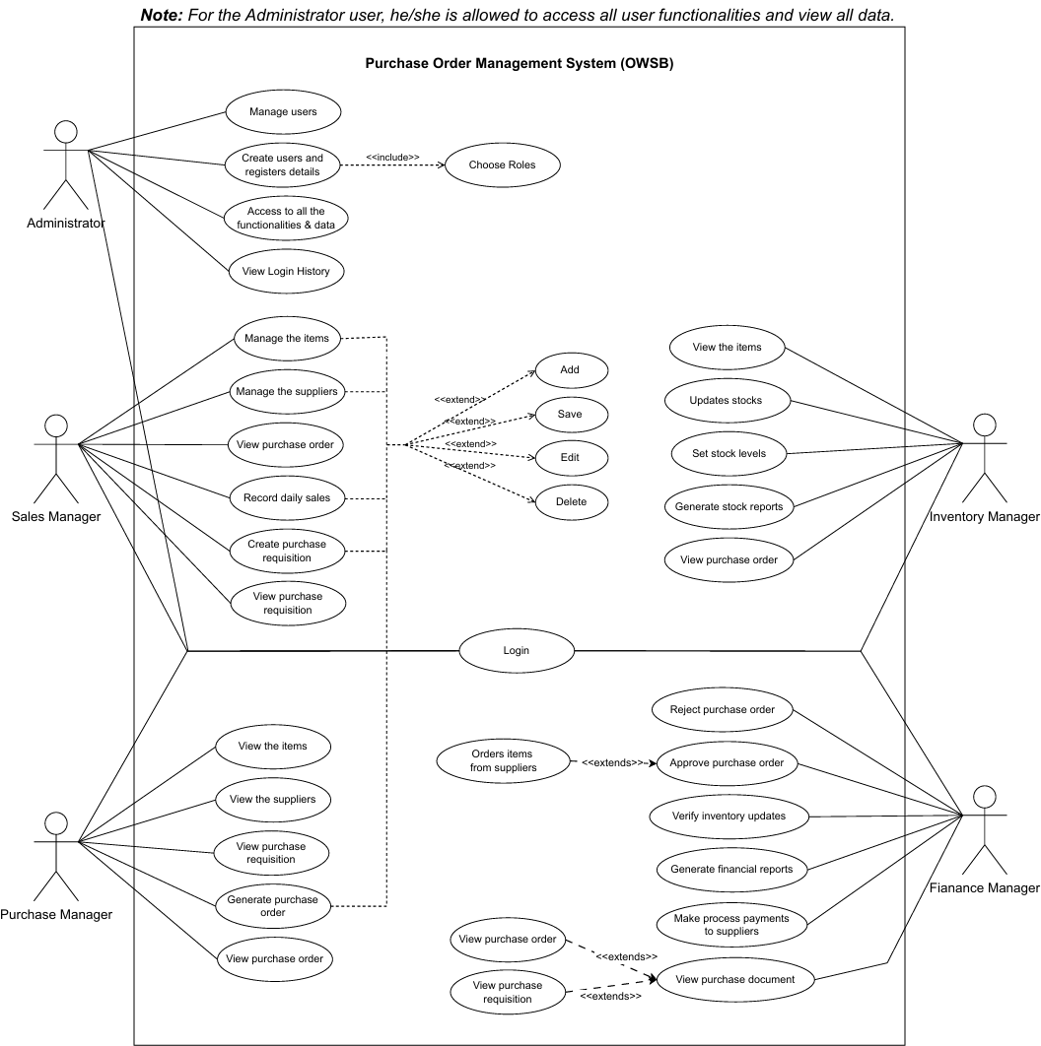

Figure 1: Use Case Diagram of Automated Purchase Order Management System (OWSB)

A UML use case diagram is the primary form of system or software requirements for a new software program underdeveloped. The use case diagram used for describing a set of user scenarios by showing the relationships between actors and use cases in a system for capturing user requirements. This UML use case diagram above represent all functional requirements of the Purchase Order Management System (OWSB). The actors of this system include Administrator, Sales Manager, Purchase Manager, Inventory Manager and Finance Manager. Each actors contains their own use case in this system.

### 1.1.1 Use Case Specification

#### 1.1.1.1 Manage Users (Administrator)

|  |  |
| --- | --- |
| **Use Case** | Manage users |
| **Brief Description** | Allows the administrator to view, edit, or delete system users. |
| **Actors** | Administrator |
| **Preconditions** | Administrator must be logged in to system with valid admin credentials. |
| **Main Flow** | 1. Admin selects "Manage Users” in the main page. 2. Admin needs to search the user with ID or name.   (ref. Alternative Flows)   1. The system will display the user details and make sure the user exists in the system. (ref. Alternative Flows) 2. Admin may choose to edit or delete option after the user exists.   (ref. Alternative Flows)   1. The system validates the changes provided and displays a message for successfully edited or deleted the user. |
| **Alternative Flows** | b) (i) If user file cannot be loaded, system shows error.  c) (i) If invalid data is entered, system prompts for correction. Admin needs to check any typing error in the User ID or name.  d) (i) If the user does not exist, the option of edit and delete button will be locked. |

#### 1.1.1.2 Create users and registers details (Administrator)

|  |  |
| --- | --- |
| **Use Case** | Create users and registers details |
| **Brief Description** | Admins create a new user and assign the roles. |
| **Actors** | Administrator |
| **Preconditions** | Administrator must be logged in to system with valid admin credentials. |
| **Main Flow** | 1. Admin selects “Manage Users” in the main page. 2. Admin click the “Add User >” button. 3. The admin needs to fill up all the details of the new user and select the roles. (ref. Alternative flow) 4. Admin will click the “Add >” button after done filled up the details. 5. The system validates and displays a message for successfully added the user. |
| **Alternative Flows** | c) (i) If data fields are incomplete or role not selected, system will prompt a message and prevent submission. |

#### 1.1.1.3 Choose Roles (Administrator)

|  |  |
| --- | --- |
| **Use Case** | Choose roles |
| **Brief Description** | Allows the administrator must assign a role to new user during the adding new user process. |
| **Actors** | Administrator |
| **Preconditions** | * Administrator must be logged in to system with valid admin credentials. * Admin is in the process of creating or adding a new user. |
| **Main Flow** | 1. Admin click the “Add User >” button. 2. When admin is entering user details, there is a combo box for admin to see all roles. (e.g. Admin, Sales Manager, Inventory Manger, etc.)   (ref. Alternative Flows)   1. Admin selects role from the dropdown combo box and proceeds to save users. |
| **Alternative Flows** | b) (i) If no role is selected, system will prompt a message and prevent submission. |

#### 1.1.1.4 Access all functionalities & data (Administrator)

|  |  |
| --- | --- |
| **Use Case** | Access all functionalities & data |
| **Brief Description** | Grants admin full access to all users functionalities and view all data. |
| **Actors** | Administrator |
| **Preconditions** | * Administrator must be logged in to system with valid admin credentials. |
| **Main Flow** | 1. Admin login to the main page. 2. System will show those roles button in the main page (e.g. Sales Manager Page, Purchase Manager Page, etc.) 3. Admin click those roles button to proceed to pages accordingly. |
| **Alternative Flows** | N/A. |

#### 1.1.1.5 View Login History (Administrator)

|  |  |
| --- | --- |
| **Use Case** | View Login History |
| **Brief Description** | Admin can view the Login History Table that contains User ID, Role, Timestamp. |
| **Actors** | Administrator |
| **Preconditions** | * Administrator must be logged in to system with valid admin credentials. |
| **Main Flow** | 1. Admin selects “Manage Users” in the main page. 2. Admin click the “View Login History” button. 3. System will show out a table that contains all data of login history. |
| **Alternative Flows** | N/A. |

#### 1.1.1.5 Manage the items (Sales Manager)

|  |  |
| --- | --- |
| **Use Case** | Manage the items |
| **Brief Description** | Sales manager can add new items, edit and delete items. Sales manager can insert new item’s name, price, stock and its supplier ID. |
| **Actors** | Sales Manager |
| **Preconditions** | * Sales manager must be logged in to system with valid manager credentials. * Sales manager is in the process of adding or editing a new item. |
| **Main Flow** | 1. Sales managers click button “Item Management” from Dashboard. 2. After click inside, it will show a table with details of each item and below the table is the input form. 3. Sales manager can insert the details of new item like item’s name, price, stock we added and its supplier ID. 4. Sales manager can edit and delete the item details. 5. Once sales manager click “Add” button, the item details may show on the table above. |
| **Alternative Flows** | N/A. |

#### 1.1.1.6 Manage the suppliers (Sales Manager)

|  |  |
| --- | --- |
| **Use Case** | Manage the suppliers |
| **Brief Description** | Sales manager can insert supplier details. After insert all detail, sales manager can add new supplier and edit or delete supplier. |
| **Actors** | Sales Manager |
| **Preconditions** | * Sales manager must be logged in to system with valid manager credentials. * Sales manager is in the process of adding or editing a new supplier. |
| **Main Flow** | 1. Sales managers click button “Sales Manager” from Dashboard. 2. After click inside, it will show a list with details of each supplier and above the list is the input form. 3. Sales manager can insert the details of new supplier like supplier ID, supplier name, contact detail and item ID. 4. Sales manager can click “Add” button to add new supplier. 5. Once sales manager click “Add” button, the supplier details may show on the list below. 6. Sales manager can select a supplier at the supplier list and edit or delete the supplier. |
| **Alternative Flows** | N/A |

#### 1.1.1.7 View purchase order (Sales Manager)

|  |  |
| --- | --- |
| **Use Case** | View purchase order |
| **Brief Description** | Sales manager can view details of purchase orders. |
| **Actors** | Sales Manager |
| **Preconditions** | * Sales manager must be logged in to system with valid manager credentials. * Sales manager is in the process of viewing purchase orders. |
| **Main Flow** | 1. Sales managers click button “View Purchase Orders” from Dashboard. 2. After click inside, it will show a table with details of each purchase order. Detail including PO ID, Item ID, Product Name, Quantity, Supplier ID, Supplier Name, Requisition ID, Price per Stock, Total Price, Purchase Date, Purchasing Status and Purchase manager name. |
| **Alternative Flows** | N/A |

#### 1.1.1.8 Record daily sales (Sales Manager)

|  |  |
| --- | --- |
| **Use Case** | Record daily sales |
| **Brief Description** | Sales manager can insert and add the item ID and quantity sold on that day. |
| **Actors** | Sales Manager |
| **Preconditions** | * Sales manager must be logged in to system with valid manager credentials. * Sales manager is in the process of adding or updating a new sales record. |
| **Main Flow** | 1. Sales managers click button “Daily Sales Entry” from Dashboard. 2. After click inside, it will show a table with details of each item, quantity and date that sold on that day. 3. Sales manager can insert item ID, and its quantity sold on a day. 4. Sales manager can click “Add” button to add new sales record. 5. Once sales manager click “Add” button, the sales record may show on the table above. 6. Sales manager can select a sales record at the table and insert a new quantity sold and click “Update” button to update its sales record. |
| **Alternative Flows** | N/A |

#### 1.1.1.9 Create purchase requisition (Sales Manager)

|  |  |
| --- | --- |
| **Use Case** | Create purchase requisition |
| **Brief Description** | Sales manager can insert purchase item’s detail and add them to purchase requisition. |
| **Actors** | Sales Manager |
| **Preconditions** | * Sales manager must be logged in to system with valid manager credentials. * Sales manager is in the process of adding and save a new purchase requisition. |
| **Main Flow** | 1. Sales managers click button “Create Purchase Requisition” from Dashboard. 2. After click inside, sales manager can insert sales manager ID, item ID and quantity to create purchase requisition. 3. After sales manager click “Add item” button, the requisition details may show at the table below. 4. The system will auto generated requisition ID and Date that create requisition. 5. After checking the details of requisition, sales manager can click “Save Requisition” button to save the purchase requisition. |
| **Alternative Flows** | N/A |

#### 1.1.1.10 View purchase requisition (Sales Manager)

|  |  |
| --- | --- |
| **Use Case** | View purchase requisition |
| **Brief Description** | Sales manager can view details of purchase requisitions. |
| **Actors** | Sales Manager |
| **Preconditions** | * Sales manager must be logged in to system with valid manager credentials. * Sales manager is in the process of viewing purchase requisition. |
| **Main Flow** | 1. Sales managers click button “View Purchase Requisitions” from Dashboard. 2. After click inside, it will show a table with details of each purchase requisition. Detail including Requisition ID, Sales Manager ID, Date, Item ID and Quantity. |
| **Alternative Flows** | N/A |

#### 1.1.1.11 View items (Purchase Manager)

|  |  |
| --- | --- |
| **Use Case** | View items |
| **Brief Description** | Purchase Manager view the item list for confirmation. |
| **Actors** | Purchase Manager |
| **Preconditions** | * Purchase manager must be logged in to system with valid manager credentials. * Purchase manager can view item details in table list. |
| **Main Flow** | 1. Inventory managers click button “View Items” from Dashboard. 2. After clicking the button, it will display a table and a button “Back”. 3. The system will read the item.txt file and displays the item details in the table. Besides, when view the table is not allowed to edit. 4. Lastly, manager click button “Back” to back to the previous page. |
| **Alternative Flows** | N/A |

#### 1.1.1.12 View suppliers (Purchase Manager)

|  |  |
| --- | --- |
| **Use Case** | View suppliers |
| **Brief Description** | The Purchase Manager views a list of all registered suppliers and their details such as supplier ID, name, contact information. |
| **Actors** | Purchase Manager |
| **Preconditions** | * The user must be logged in as a Purchase Manager. * The suppliers.txt file must exist and be formatted correctly. |
| **Main Flow** | 1. The Purchase Manager opens the Supplier Viewer window with clicking the button ‘view supplier’. 2. The system reads data from suppliers.txt. 3. The system displays the supplier details in a table format. 4. The Purchase Manager can view the supplier ID, name, and other details in each row. 5. Click ‘close’ to exit. |
| **Alternative Flows** | When suppliers.txt file not found or unreadable, system shows an error message and disables the supplier table view. |

#### 1.1.1.13 View purchase requisition (Purchase Manager)

|  |  |
| --- | --- |
| **Use Case** | View purchase requisition |
| **Brief Description** | Purchase Manager views a list of purchase requisitions raised by Sales Manager and select requisitions to generate purchase orders. |
| **Actors** | Purchase Manager |
| **Preconditions** | * The user must be logged in as a Purchase Manager. * At least one purchase requisition must exist in the system. |
| **Main Flow** | 1. The Purchase manager opens the Purchase Requisition Viewer in Purchase Manager Dashboard. 2. The system displays a table of all requisitions with relevant details (Requisition ID, Item ID, Quantity, Sales Manager ID and Date). 3. Purchase manager selects a requisition. 4. Purchase manager clicks "Generate PO" to create a purchase order from the selected requisition. 5. Click ‘back’ to return to Dashboard. |
| **Alternative Flows** | 1. The system will show a message "No requisitions available" if the requisition file is empty or not found. 2. When generate PO, the system will show a message “Please select a requisition” if a requisition is not selected. |

#### 1.1.1.14 Generate purchase order (Purchase Manager)

|  |  |
| --- | --- |
| **Use Case** | Generate purchase order |
| **Brief Description** | The Purchase Manager generates a new Purchase Order (PO) based on a Purchase Requisition. The system fetches related item and supplier details automatically and allows the manager to review and confirm the PO before saving. |
| **Actors** | Purchase Manager |
| **Preconditions** | * The user must be logged in as a Purchase Manager. * A valid, approved Purchase Requisition must be selected. * Item and Supplier information files (items.txt, suppliers.txt) must be present and correctly formatted. |
| **Main Flow** | 1. The Purchase Manager selects a requisition from the Requisition Viewer. 2. The manager clicks the "Generate PO" button. 3. The system reads the items.txt and suppliers.txt files to fetch the item name, supplier ID, unit price, and supplier name based on the selected requisition. 4. The system automatically generates a new PO ID, sets the status to "Pending", generate a date base on system time and calculate total price and add a purchase manager name base on the user who login. 5. A confirmation window appears to review the PO details. 6. Upon confirmation, the PO is saved into purchase_orders.txt. |
| **Alternative Flows** | 1. When generate PO, the system will show a message “Item or Supplier info not found” if a requisition is selected but item or supplier is not exist in file. 2. If user cancel the confirmation, PO will not saved and the system returns to the Requisition list without changes. |

#### 1.1.1.15 View purchase order (Purchase Manager)

|  |  |
| --- | --- |
| **Use Case** | View purchase order |
| **Brief Description** | Purchase Manager can view, edit or delete the list of existing Purchase Orders. |
| **Actors** | Purchase Manager |
| **Preconditions** | * The user must be logged in as a Purchase Manager. * The purchase_orders.txt file must exist and contain at least one entry. |
| **Main Flow** | 1. The Purchase Manager open the Purchase Manager Dashboard. 2. The system reads data from purchase_orders.txt. 3. The system loads and displays all purchase order records in a non-editable table. 4. The Purchase Manager can scroll through or search by PO ID or status (“Rejected”) to find specific records. 5. Upon selecting a row, user can choose to edit the quantity of the row or delete the PO order. 6. After editing the quantity of the PO, total will change according to quantity, date will change based on changes and status will change to ‘pending’. 7. When click ‘save’ button, system will save the changes to purchase_order.txt. |
| **Alternative Flows** | 1. When user click the button ‘close’, system will prompt user to save changes before exit. 2. If purchase_orders.txt is missing or corrupted, the system displays an error message and disables the table view. |

#### 1.1.1.16 View List of Items (Inventory Manager)

|  |  |
| --- | --- |
| **Use Case** | View Item Details |
| **Brief Description** | Allows the Inventory Manager to view item details. |
| **Actors** | Inventory Manager |
| **Preconditions** | * Inventory manager must be logged in to system with valid manager credentials. * Inventory manager can view item details in table list. |
| **Main Flow** | 1. Inventory Manager click button “View List of Items” from main page. 2. After clicking the button, the manager will be taken to the "View List of Items" page, which will display a table, a combo box and a button “Back”. 3. Then, the table has read the item text file and displays the item details in the table. Besides, when view the table is not allowed to edit. 4. In addition, combo box has read the Item ID/Item Name from the item text file so that the manager can select what needs to be viewed and highlight the matching row in the table. 5. Lastly, manager click button “Back” to back to the previous page. |
| **Alternative Flows** | N/A |

#### 1.1.1.17 Updates stocks (Inventory Manager)

|  |  |
| --- | --- |
| **Use Case** | Update stock based on received items from approved Purchase Orders (POs). |
| **Brief Description** | Allows the Inventory Manager to update stocks. |
| **Actors** | Inventory Manager |
| **Preconditions** | * Inventory manager must be logged in to system with valid manager credentials. * Inventory manager can update stocks based on received items from approved Purchase Orders (POs) |
| **Main Flow** | 1. Inventory Manager click button “Update Stocks” from main page. 2. After clicking the button, the manager will be taken to the "Update Stocks" page, which will display a table and button “Back”, button “Update” and button “Save”. 3. Then, the table has read the Order text file and displays the order details in the table. Besides, when view the table is not allowed to edit. 4. In addition, manager click button “Back” to back to the previous page. 5. Moreover, the manager click button “Update” can edit table. 6. Lastly, the manager click button “Save” then the inputs will also be saved in the table and in the Order text file. |
| **Alternative Flows** | e) (i) When the manager click button “Save”, it will pop up a confirm dialog  “Are you sure want to update Stocks?”. If click “Yes” then allow to edit table, on the contrary click “No” not allow edit table.  f) (i) When the manager click button “Save”, it will save that manager previous edit table’s data and will save in Order text file. |

#### 1.1.1.18 Set stock level (Inventory Manager)

|  |  |
| --- | --- |
| **Use Case** | Set stock level |
| **Brief Description** | Allows the Inventory Manager view stock levels and track low-stock alerts. |
| **Actors** | Inventory Manager |
| **Preconditions** | * Inventory manager must be logged in to system with valid manager credentials. * Inventory manager can view stock levels and track low-stock alerts. |
| **Main Flow** | 1. Inventory Manager click button “Set Stock Levels” from main page. 2. After clicking the button, the manager will be taken to the "Set Stock Levels" page, which will display a table and a button “Back”. 3. Then, the table has read the item text file and displays the item details in the table. Besides, when view the table is not allowed to edit. 4. Lastly, the manager click button “Back” to back to the previous page. |
| **Alternative Flows** | c) (i) If the item’s total stock is less than 50, stock level will show “LOW STOCK”. On the contrary, the item’s total stock is more than 50, stock level will show “HIGH STOCK”. |

#### 1.1.1.19 Generate stock reports (Inventory Manager)

|  |  |
| --- | --- |
| **Use Case** | Generate stock reports |
| **Brief Description** | Allows the Inventory Manager view and generate stock reports. |
| **Actors** | Inventory Manager |
| **Preconditions** | * Inventory manager must be logged in to system with valid manager credentials. * Inventory manager can view purchase order. |
| **Main Flow** | 1. Inventory Manager click button “Generate Stock Reports” from main page. 2. After clicking the button, the manager will be taken to the "Generate Stock Reports" page, which will display a table, a combo box, button “Export” and button “Back”. 3. Then, the table has read the item text file and displays the item details in the table. Besides, when view the table is not allowed to edit. 4. In addition, click button “Export” the table will be export in CSV. 5. Lastly, the manager click button “Back” to back to the previous page. |
| **Alternative Flows** | N/A |

#### 1.1.1.20 View purchase order (Inventory Manager)

|  |  |
| --- | --- |
| **Use Case** | View purchase order |
| **Brief Description** | Allows the Inventory Manager view purchase order. |
| **Actors** | Inventory Manager |
| **Preconditions** | * Inventory manager must be logged in to system with valid manager credentials. * Inventory manager can view purchase orders to verify received items. |
| **Main Flow** | 1. Inventory managers click button “View Purchase Order” from main page. 2. After clicking the button, the manager will be taken to the "View Purchase Order" page, which will display a table, a combo box and a button “Back”. 3. Then, the table has read the PO text file and displays the PO details in the table. Besides, when view the table is not allowed to edit. 4. In addition, combo box has read the PO ID/Item ID from the PO text file so that the manager can select what needs to be viewed and highlight the matching row in the table. 5. Lastly, the manager click button “Back” to back to the previous page. |
| **Alternative Flows** | N/A |

#### 1.1.1.21 Approves purchase order (Finance Manager)

|  |  |
| --- | --- |
| **Use Case** | Approve purchase order |
| **Brief Description** | Finance Manager should approve the Purchase Order which made from the Purchase Manager. |
| **Actors** | Finance Manager |
| **Preconditions** | * Finance manager must be logged in to system with valid manager credentials. * Purchase order has made by the Purchase Manager |
| **Main Flow** | 1. Finance Manager enter “Purchase order” page. 2. Finance Manager select the Pending tab. 3. A list of Purchase Order will show in the table. 4. Finance Manager should select Purchase Order that he want to approve. 5. After selecting, Finance Manager should click the “Approve” button to approve the Purchase Order. 6. A message box will be prompted to show the action is succussed. |
| **Alternative Flows** | * If the file can’t be written, a message box will prompt to notice the user file can’t be written. |

#### 1.1.1.22 Reject purchase order (Finance Manager)

|  |  |
| --- | --- |
| **Use Case** | Reject purchase order |
| **Brief Description** | Finance Manager should approve the Purchase Order which made from the Purchase Manager. |
| **Actors** | Finance Manager |
| **Preconditions** | * Finance manager must be logged in to system with valid manager credentials. * Purchase order has made by the Purchase Manager |
| **Main Flow** | 1. Finance Manager enter “Purchase order” page. 2. Finance Manager select the Pending tab. 3. A list of Purchase Order will show in the table. 4. Finance Manager should select Purchase Order that he want to reject. 5. After selecting, Finance Manager should click the “Reject” button to approve the Purchase Order. 6. A message box will be prompted to show the action is succussed. |
| **Alternative Flows** | * If the file can’t be written, a message box will prompt to notice the user file can’t be written. * After rejecting the Purchase Order, the Purchase Manager should edit the quantity or item and raise the Purchase Order again. |

#### 1.1.1.23 Order Items from suppliers (Finance Manager)

|  |  |
| --- | --- |
| **Use Case** | Order Items from suppliers |
| **Brief Description** | After approving the Purchase Order, Finance Manager should place the order to the respective Supplier. |
| **Actors** | Finance Manager |
| **Preconditions** | * Finance manager must be logged in to system with valid manager credentials. * Purchase order should be approved by the Finance Manager |
| **Main Flow** | 1. Finance Manager enter “Purchase order” page. 2. Finance Manager select the Approved tab. 3. A list of Purchase Order will show in the table. 4. Finance Manager should select Purchase Order from the same supplier to make order. 5. After selecting, Finance Manager should click the “Place Order” button to place the order. 6. An Order Confirmation page will be prompt which show the details of the order. 7. After checking the details, Finance Manager should click button “Confirm” to make the order. 8. A message box will be prompted if the action has succeeded. |
| **Alternative Flows** | * If Finance Manager select items that came from different Supplier, it will prompt an error message box which shows order can’t be made by different supplier. |

#### 1.1.1.24 Verify inventory updates (Finance Manager)

|  |  |
| --- | --- |
| **Use Case** | View inventory updates |
| **Brief Description** | After Inventory updated the status and quantity received of the order, Finance Manager should verify it. |
| **Actors** | Finance Manager |
| **Preconditions** | * Finance manager must be logged in to system with valid manager credentials. * Order should be updated by the Inventory Manager |
| **Main Flow** | 1. Finance Manager enter “Inventory Verification” page. 2. A list of Updated Order will show in the table. 3. Finance Manager should check whether the order quantity is same to the received quantity. 4. After checking, the Finance Manager should select the order and select “Verify” button. 5. A message box will be prompted if the action has succeeded. |
| **Alternative Flows** | N/A |

#### 1.1.1.25 Generate financial reports (Finance Manager)

|  |  |
| --- | --- |
| **Use Case** | Generate financial reports |
| **Brief Description** | Finance Manager can generate monthly report to view and download. |
| **Actors** | Finance Manager |
| **Preconditions** | * Finance manager must be logged in to system with valid manager credentials. |
| **Main Flow** | 1. Finance Manager enter “Generate Report” page. 2. Finance Manager select the month and year of report he wants to generate. 3. After selecting the month and year, Finance Manager should click the button “Generate” to generate the monthly report. 4. A list of order and summary will be shown to the Finance Manager. 5. Finance Manager can click “Export file” to export the report in CSV format. 6. A message box will be prompted if the file has exported successfully. |
| **Alternative Flows** | N/A |

#### 1.1.1.26 Make process payments to supplier (Finance Manager)

|  |  |
| --- | --- |
| **Use Case** | Make process payments to supplier |
| **Brief Description** | After received all item in an order, the Finance Manager should make payment for that order. |
| **Actors** | Finance Manager |
| **Preconditions** | * Finance manager must be logged in to system with valid manager credentials. * All items in the order have been received and verified. |
| **Main Flow** | 1. Finance Manager enter “Make Payment” page. 2. A list of order that haven’t been paid will be shown in the table. 3. The system will calculate the total item and item received from each order. If the order is completely received, it will show “Ready to Pay”. 4. Finance Manager should select order that are “Ready to Pay” and click button “Make Payment”. 5. A payment confirmation will be prompt and details of the order will be shown. 6. After confirming the payment, Finance Manager should click the “Confirm” button to complete the payment. 7. A message box will be prompted if the action has succeeded. |
| **Alternative Flows** | * If the Finance Manager select order that haven’t been completed (received), a warning message box will prompt out shows that it is an invalid action. |

#### 1.1.1.27 View purchase order (Finance Manager)

|  |  |
| --- | --- |
| **Use Case** | View purchase order |
| **Brief Description** | Finance Manager can view Purchase Order that raised by Purchase Manager. |
| **Actors** | Finance Manager |
| **Preconditions** | * Finance manager must be logged in to system with valid manager credentials. |
| **Main Flow** | 1. Finance Manager enter “Purchase Order” page. 2. Purchase Order are grouped in tab with the remaining status (Pending, Approved, Ordered) 3. Finance Manager can select the tab to view the Purchase Order. 4. A list of Purchase Order will show in the table. |
| **Alternative Flows** | * If the file can’t be written, a message box will prompt to notice the user file can’t be written. |

#### 1.1.1.28 View purchase requisition (Finance Manager)

|  |  |
| --- | --- |
| **Use Case** | View purchase requisition |
| **Brief Description** | Finance Manager can view Purchase Requisition that raised by Sales Manager. |
| **Actors** | Finance Manager |
| **Preconditions** | * Finance manager must be logged in to system with valid manager credentials. |
| **Main Flow** | 1. Finance Manager enter “Purchase Requisition” page. 2. A list of Purchase Requisitionwill show in the table. |
| **Alternative Flows** | * If the file can’t be written, a message box will prompt to notice the user file can’t be written. |

## 

## 1.2 Class Diagram

***Note: Different thicknesses of dotted lines represent different directions in <<Interfeoace>>.***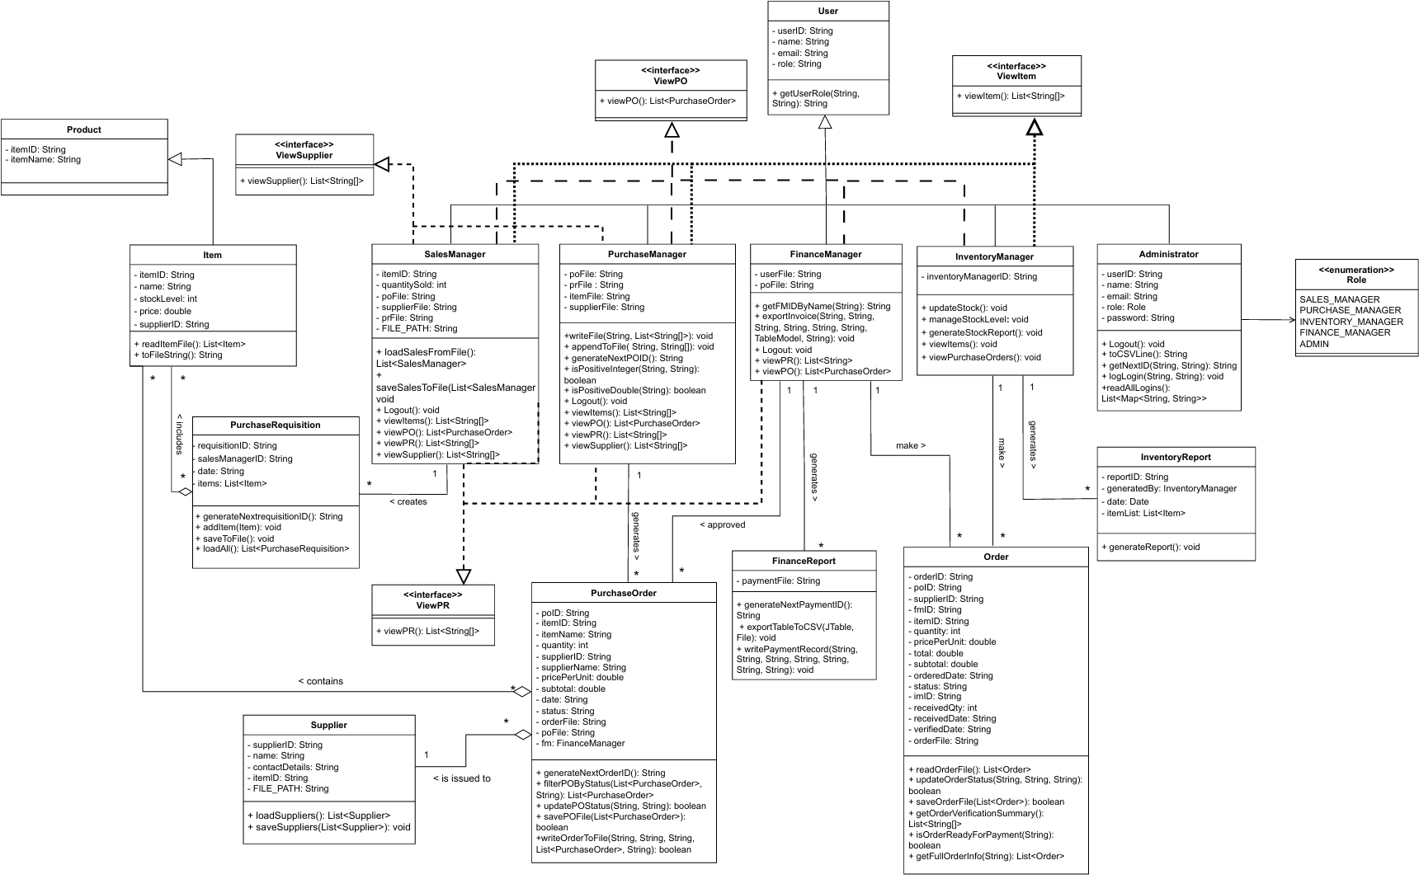

Figure 2: Automated Purchase Order Management System (OWSB)

The class diagram models the core structe of the Automated Purchase Order Management System (OWSB) using object-oriented principles. It consists various of roles such as Sales Manager, Purchase Manager, Finance Manager, Inventory Manager and Administrator. These roles are extending a superclass “User” and connecting other classes. For instance, Inventory Report , Purchase Order, Purchase Requisition and others related reports. Besides, interfaces and enumerations are also used implement role-specific contracts and promote abstraction in this class diagram.

The “User” superclass, which is at the top of hierarchy, has the following core attributes: role, email, userID, and name. It also has a method called getUserRole() that retrieves the role. By inheriting from User, all specialized user roles, which are including SalesManager, PurchaseManager, FinanceManager, InventoryManager, and Administrator, can access its common attributes and actions. The enumeration Role defines all valid user roles in the system:

SALES MANAGER, PURCHASE MANAGER, INVENTORY MANAGER, FINANCE MANAGER, ADMIN. (Role section only can choose from these five roles)

The ‘Sales Manager” class handles functionalities like loading and saving from files, accessing suppliers, creating Purchase Requisition (PR), viewing Purchase Order and so forth. Attributes include file references (poFile, prFile, itemFile, etc.) and sales-specific data like quantitySold. SaveSalesToFile(), loadSalesFromFile(), and other view...() activities are among the methods. To standardize these viewing capabilities, it additionally implements the ViewPR, ViewPO, and ViewSupplier interfaces.

Moreover, with important functions like writeFileToPO(), appendToFile(), and generateNextPOID(), the PurchaseManager manages purchase requests and creates purchase orders. In addition, it implements the ViewPR, ViewPO, and ViewSupplier interfaces and validates input. The Finance Manager's primary responsibilities include creating financial reports, confirming inventory adjustments, and authorizing purchase orders. It collaborates with FinanceReport to maintain payment data and makes use of functions like exportToCSVWithTable() and verifyPOStatus(). For relevant data access, it uses ViewPO and ViewPR.

In “Inventory Manger”, using functions like updateStock(), generateStockReport() and viewPurchaseOrders(), they also create stock reports, refreshes inventory, and maintains stock levels. Report data is stored using the InventoryReport class. Complete system control, including the ability to create users and track logins, belongs to the administrator. GetNextID(), logLogin(), and readAllLogins() are important methods. Admins can access all role dashboards

In brief, the OWSB system's class diagram successfully uses object-oriented concepts like inheritance, abstraction, and interface implementation to represent a role-based purchase order management process. While individual actions are managed by dedicated methods and helpful utility classes like Item, Supplier, PurchaseOrder, and report generators, each user role is contained in its own class and inherits common properties from a single User superclass. It also standardization and modularity across viewing functionalities are encouraged by the usage of interfaces.

# 2.0 Output of Program

**Login Page:**

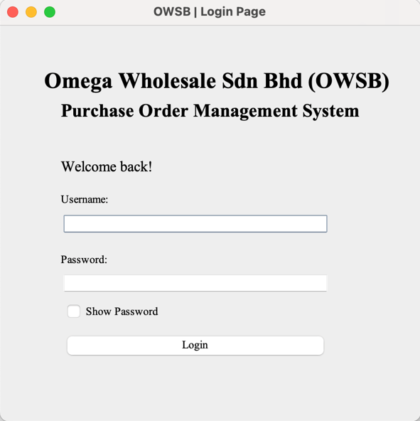

Figure 3: Login Page for OWSB system

When user start the program, a Login Page will be prompt and get Username and Password from user.

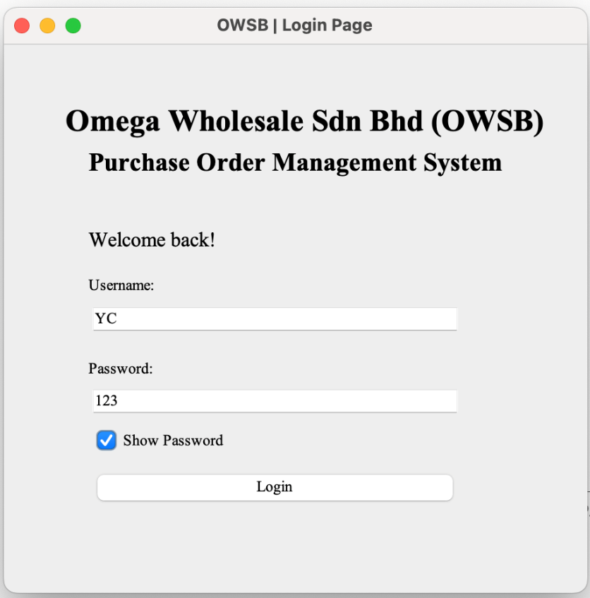

Figure 4: Key in user’s Login details

After user insert its Username and Password, it will search its username and password in the User.txt file to see its role. User can also check the “Show Password” checkbox to show its password (which is masked initial).

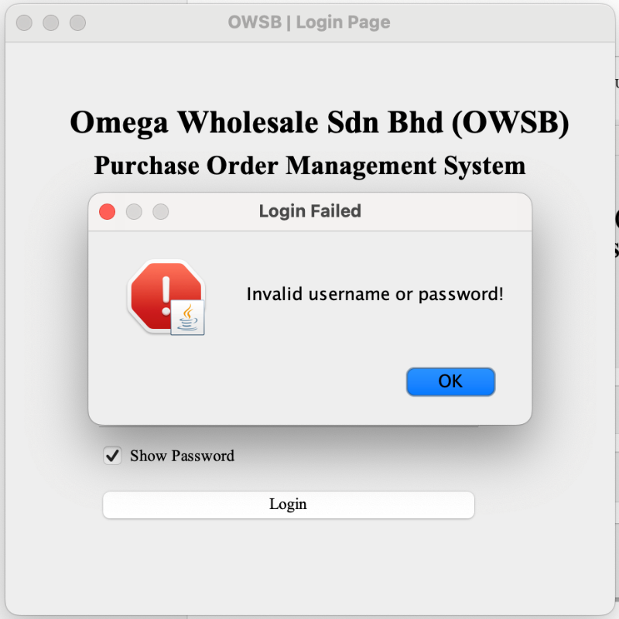

Figure 5: Dialog message of Login Failed

If the given Username or Password is wrong, which doesn;t exit in the User.txt file, it will prompt a Login Failed message box.

## 2.1 Administrator

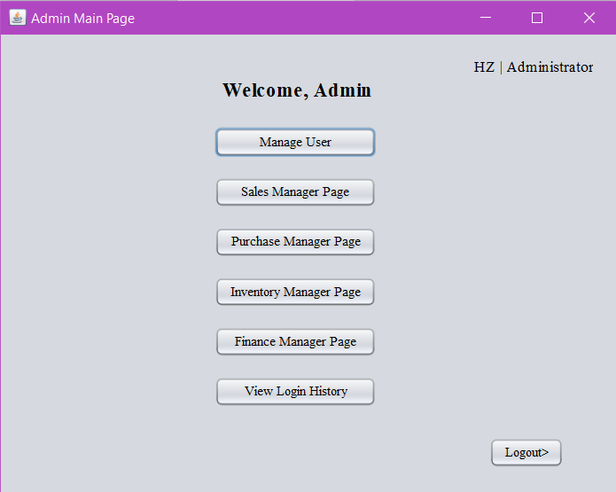

Figure 6: Main Page for Administrator

This is the Administrator “Main Page” it will show when successful login as administrator role. The “Admin Main Page” contains a list of action buttons which include link to other roles page since admin have the access to all functionalities and view the data. Besides, it also contains “Mange User“ and “View Login History” which is the main function of admin and “Logout >” button.

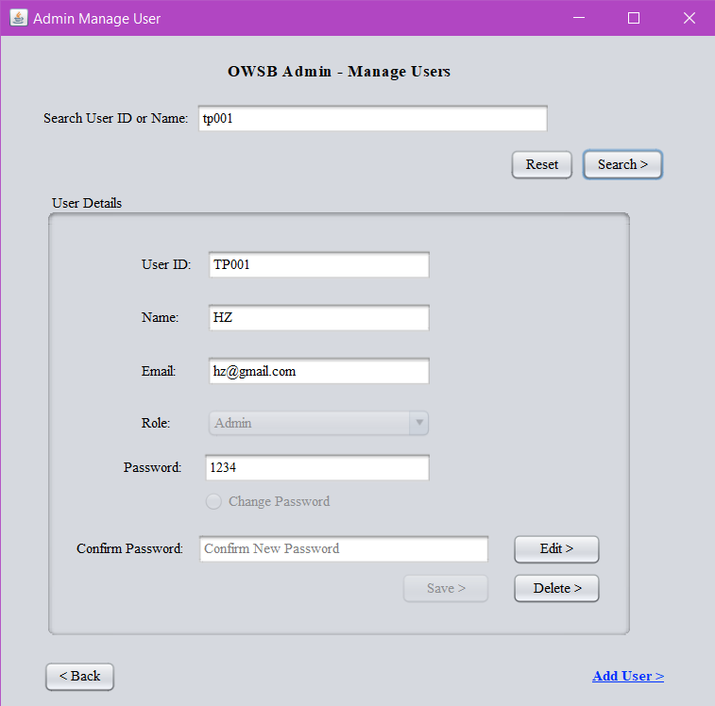

Figure 7: Manage user page for Administrator

When admin click “Mange user” button, it will prompt out this “Admin Manage User” page. The admin can search about user by using User ID or Name and type in the text fields. After clicking “Search” button, “User Details” below will automatically prompt out all the details in the corresponding box. These text fields are locked by now. If admins want to edit the details for the user, they need to click the “Edit >” button to unlock the text fields.

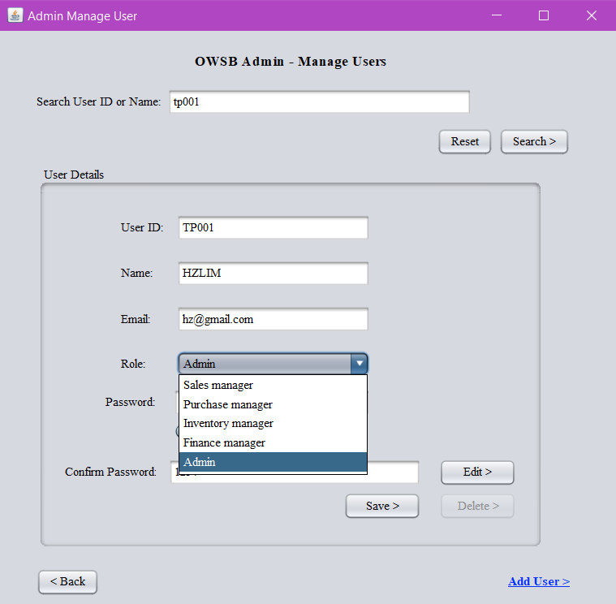

Figure 8: Edit details for user

After clicking “Edit >” button, admin is allowed to edit the username and able to change the role of the user.

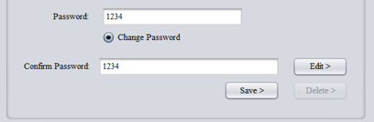

Figure 9: Change password for user

If admin need to change a new password for the user, admin is required to check the radio button “Change Password” to unlock the Password & Confirm Password text field. Besides, make sure the Confirm Password is match with the password. If not, the system will prompt a error dialog “Password Mismatch” when proceed to “Save >” button.

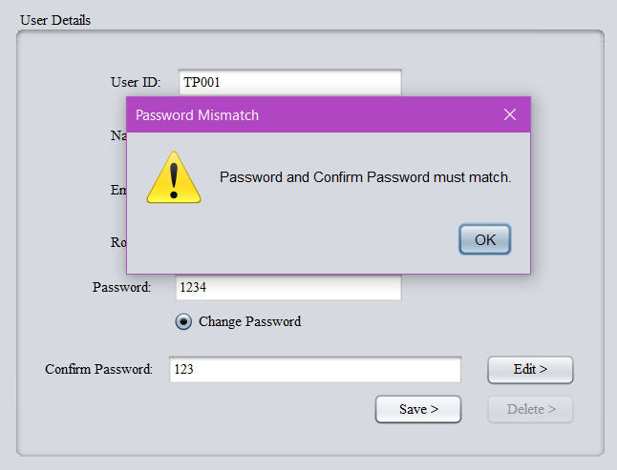

Figure 10: Dialog message of Password Mismatch for editing user

Password Mismatch. Admin need to check whether the Password text fields is same as the Confirm Password text field.

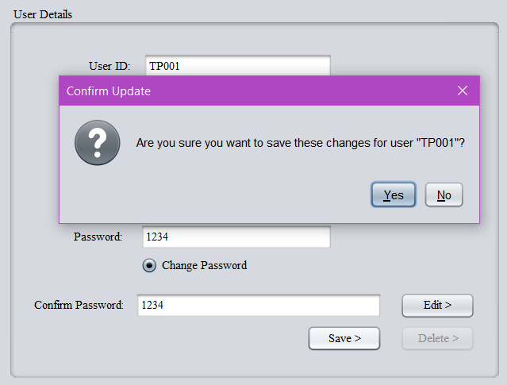

Figure 11: Dialog message of Confirm Update

If everything is correct, it will prompt out a dialog “Confirm Update” when admin clicking the “Save >” button. Admin may check again all the details whether is correct. Then, admin click “Yes” button after there is no any error and confirm update the user details.

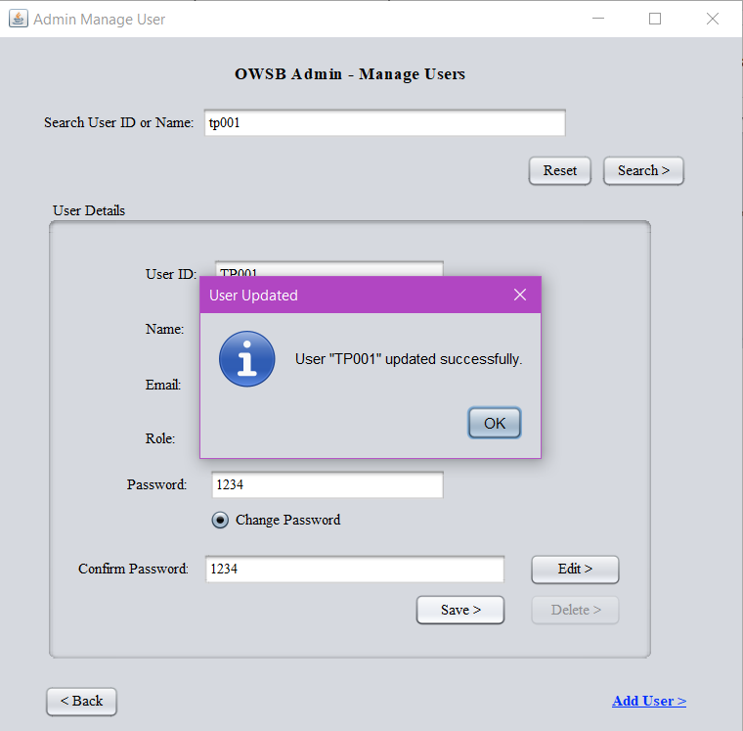

Figure 12: Dialog message of User Updated

Admin will see a dialog “User Updated” that means admin is update the user details successfully.

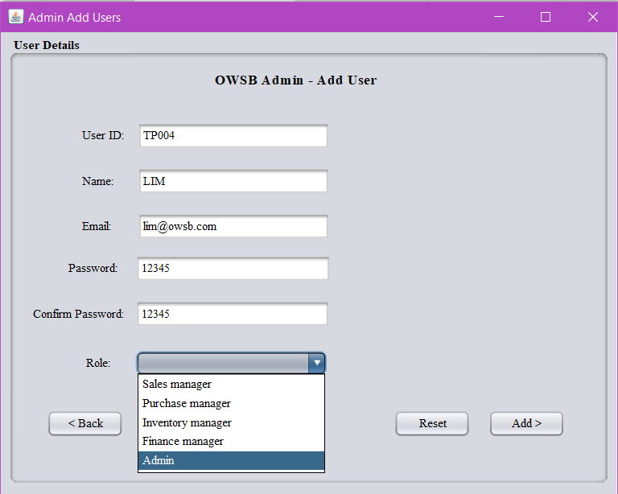

Figure 13: Admin Add Users page for Administrator

Next, admin can add a new user for our system by clicking the “Add User>” label button below the “Admin Manage User” page. It will prompt out a new window page “Admin Add Users”. Here, the User ID will generate automatically. It will follow the latest User ID in our user lists.

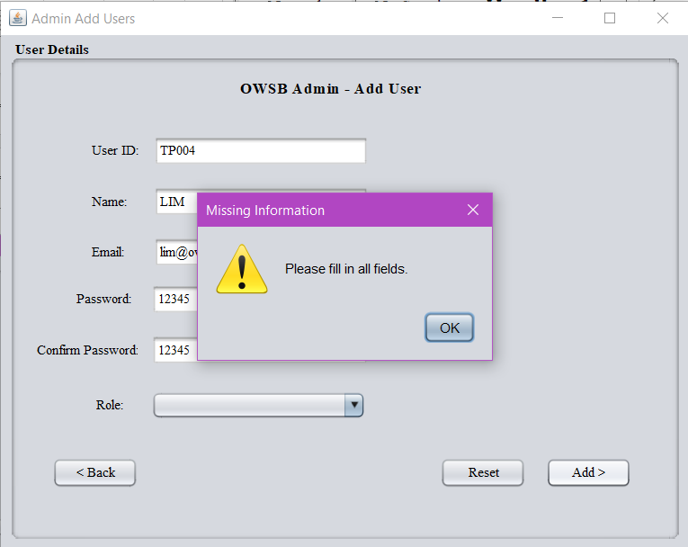

Figure 14: Dialog message of Missing Information

During the add user process, if there are some fields that haven’t fill in, for example figure above – admin didn’t select a role for the new user, it will prompt out a dialog “Missing Information” to make sure that admin must fill in all the fields.

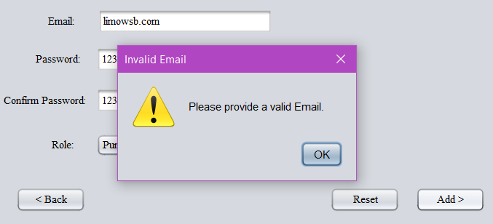

Figure 15: Dialog message of Invalid Email

If the email that provided by admin is not correct, such as missing “@” or the email is invalid, the admin will see a dialog “Invalid Email” saying that “Please provide a valid Email”

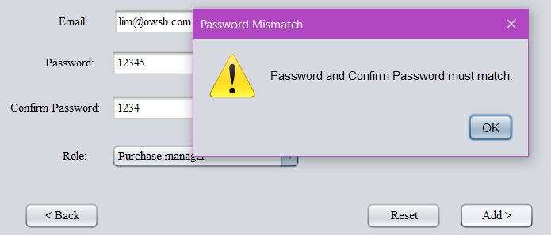

Figure 16: Dialog message of Password Mismatch for adding user

Here, for adding user, admin is also required to nake sure that Password & Confirm Password text field is match. If not, the system will prompt a error dialog “Password Mismatch” when proceed to “Add >” button. The “Reset” button below is just for admin to reset all the text field as “Blank”.

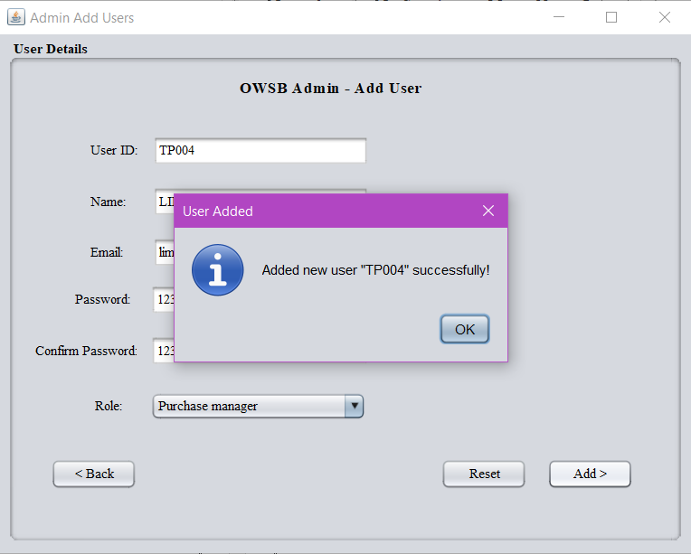

Figure 17: Dialog message of User Added

If no any error or issue as filling up the details for new user, admin can proced to the “Add >” button. Then, the system will valid and prompt a dialog “User Added” to admin saying that the new user is added successfully.

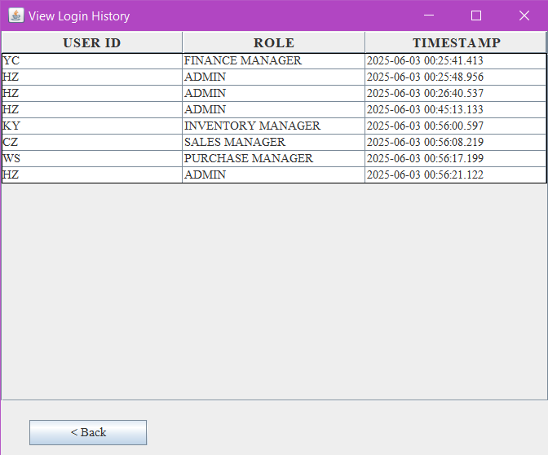

Figure 18: View Login History of Administrator

Here is a additional function for admin. When admin clicking “View Login History” button, system will prompt out this window page to admin. For here, admin can see all user login history, which includes User ID, Role, Date and Time. For example, the latest admin, named HZ, login date is 2025-06-03 and time is 00:45:13.133.

## 2.2 Sales Manager

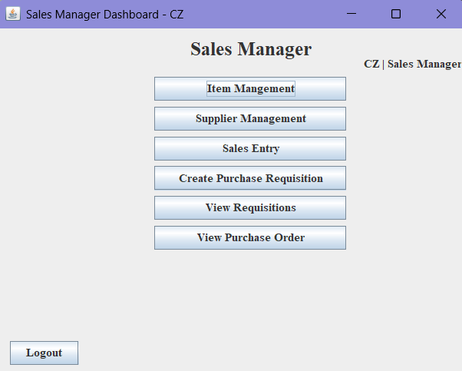

Figure 19: Home Page of Sales Manager

This is the Sales Manager “Main Page”. It will show when successful login as sales manager role. The “Sales Manager Main Page” contains a list of action buttons which include Item Management, Supplier Management, Sales Entry, Create Purchase Requisition, View Requisitions and View Purchase Order. Besides, it also contains “Logout” button, user’s name and role.

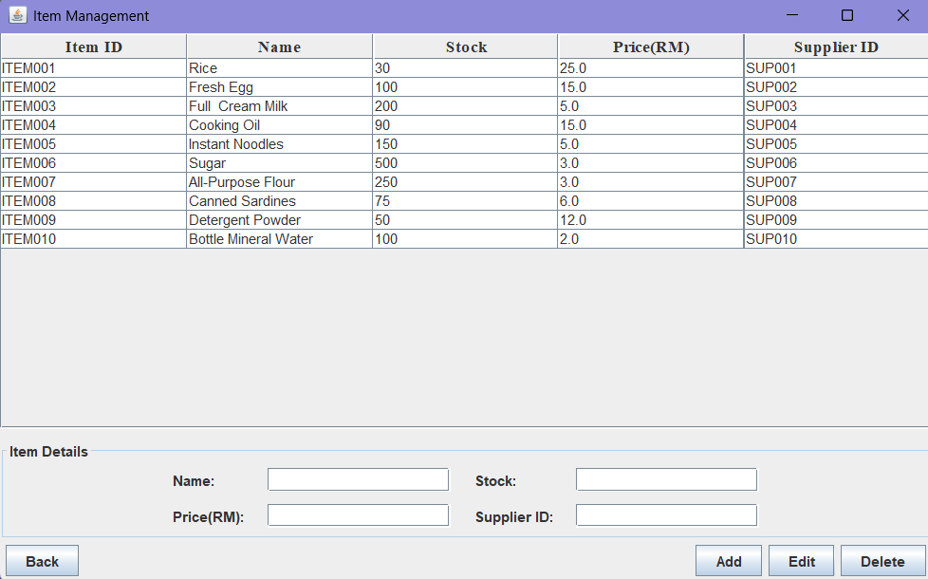

Figure 20: Item Management Page

After clicking “Item Management” button, it will show all the details of each items. Details including Item ID, Item’s name, Stock, Price per item and Supplier ID.

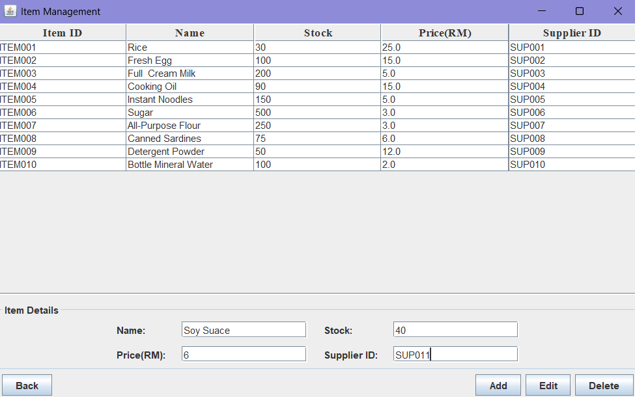

Figure 21: Insert New Item Details

Sales manager can add a new item by type in its name, price, stock and supplier’s supplier ID.

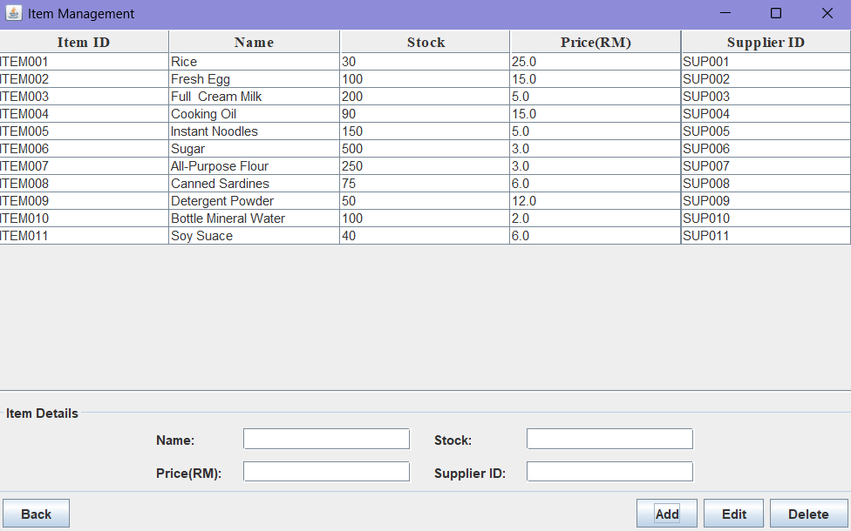

Figure 22: Add New Item

Sales manager can click “Add” button to add those details in the system. At the same time, the new item’s detail will show on the table.

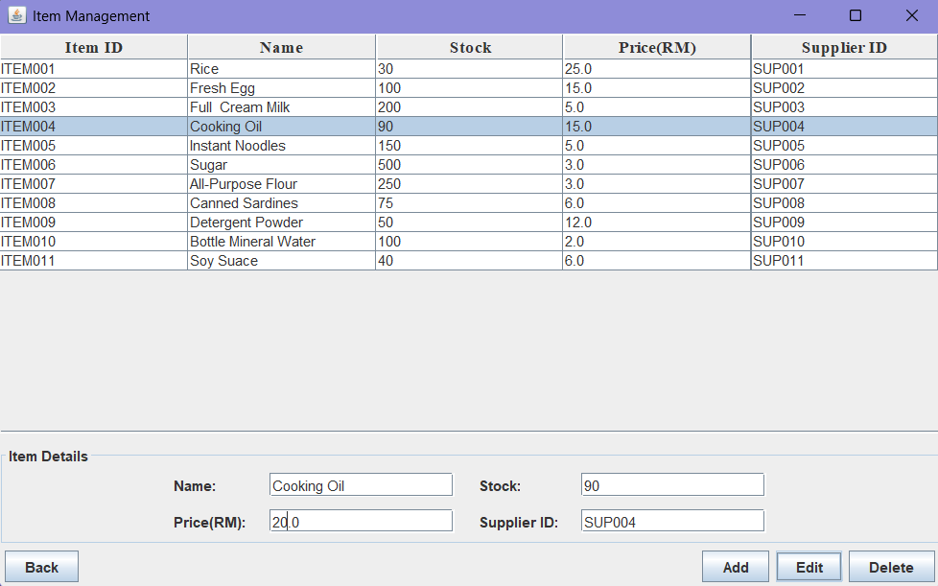

Figure 23: Edit an Item's Price

Sales manager can select a row of item to manipulate the data. Once selected a row, the details will show on the insert form. Sales manager can do editing at the “Item Details”. (At figure above shows, sales manager change price of cooking oil from RM15 to RM20.)

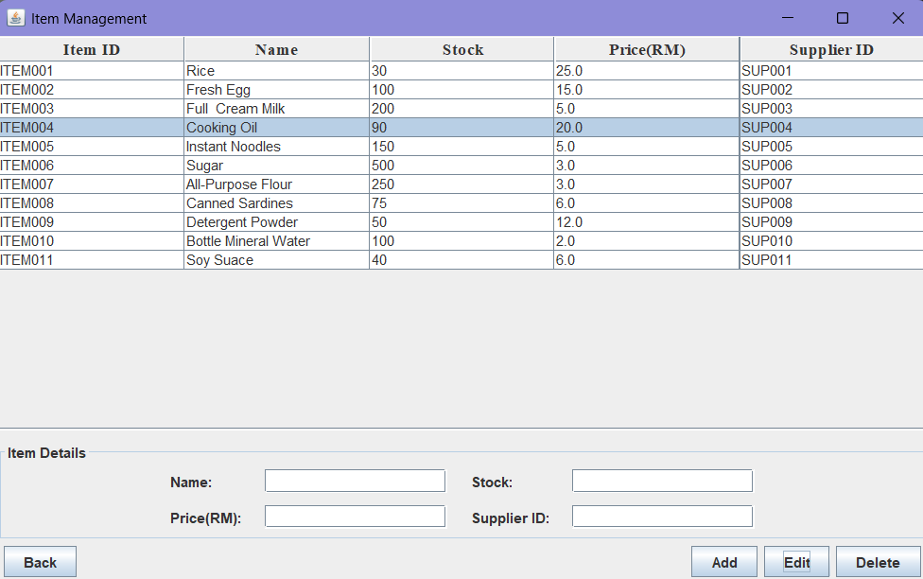

Figure 24: Price Updated Successfully

After sales manager click “Edit” button, the price of cooking oil at the table will be updated.

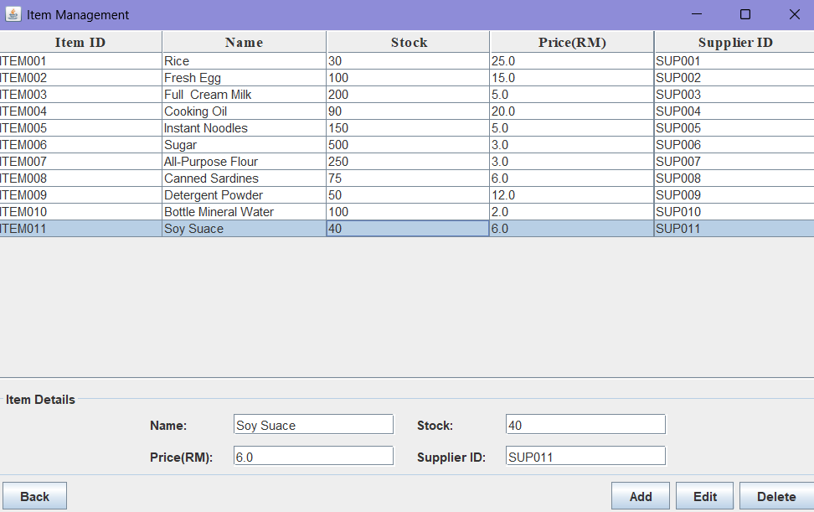

Figure 25: Delete a row of Item

If sales manager wants to delete an item, he can select a row and click “Delete” button. Figure above shows row “ITEM011” get selected.

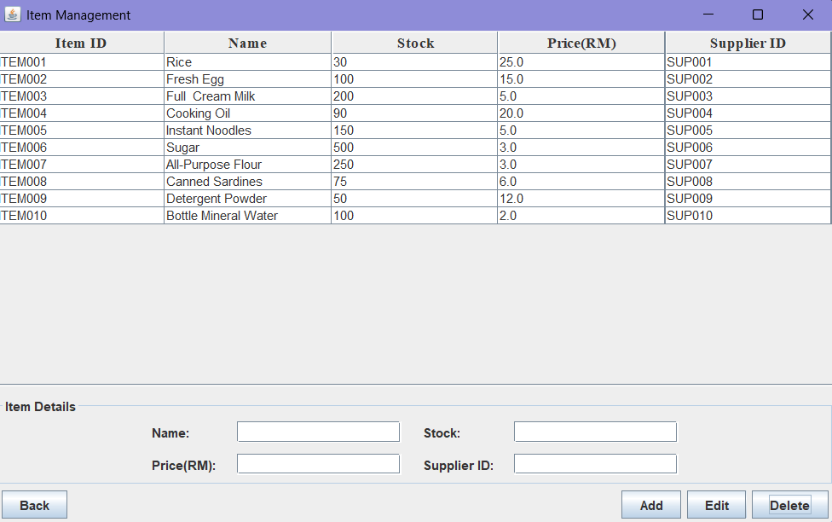

Figure 26: Delete Successfully

After sales manager click “Delete” button, the row “ITEM011” deleted. Once sales manager want to leave this page, he can click “Back” button and go back to Home Page.

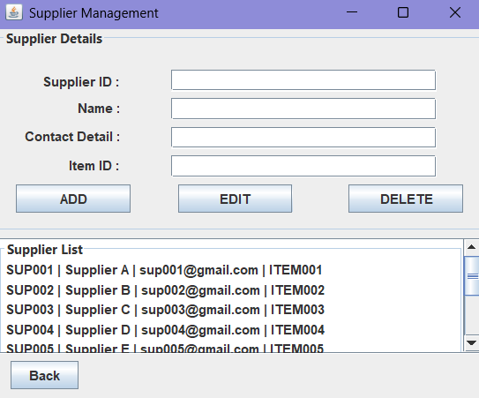

Figure 27: Supplier Management Page

After clicking button “Supplier Management”, sales manager can add new supplier by inserting supplier’s Supplier ID, Supplier Name, Supplier’s Contact Detail and Item ID of the item they supply at “Supplier Details” form. The list below the “Supplier Details” shows the details of suppliers we cooperate.

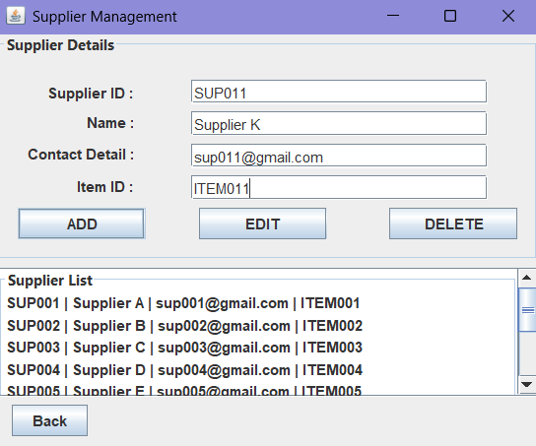

Figure 28: Adding New Supplier's Details

After inserting the details of new supplier, sales manager can click “Add” button to add new supplier.

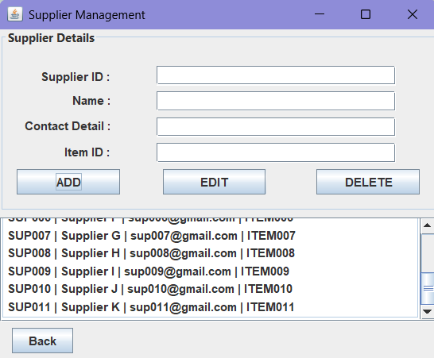

Figure 29: New Supplier Added

After clicking “Add” button, the new supplier will show at the bottom of the list.

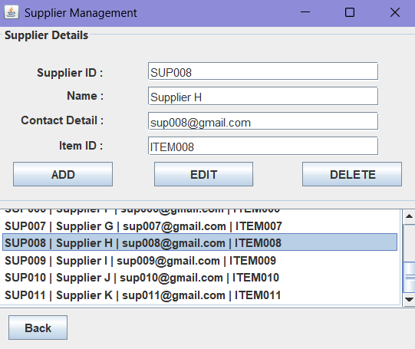

Figure 30: Select Supplier

If the item supplier get changes, sales manager can select the row of the supplier and edit their details.

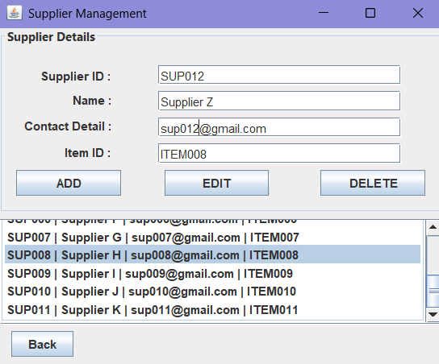

Figure 31: Changing New Supplier

As figure above shows, Supplier H (SUP008) was change to Supplier Z (SUP012). Which means the supplier of Item008 changed.

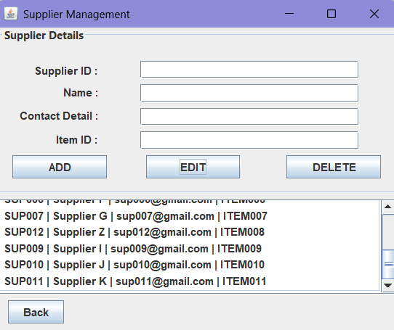

Figure 32: Supplier Replace

Once sales manager click “Edit” button, Supplier Z will successfully replace Supplier H.

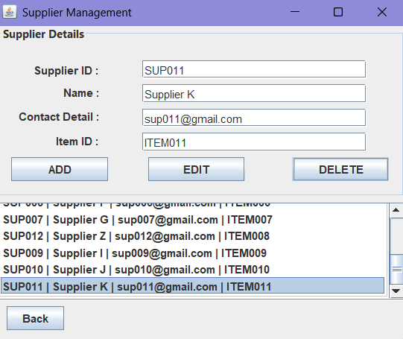

Figure 33: Delete Supplier

If sales manager wants to remove a supplier, they can select the row of the supplier they want to remove and click “Delete” button. (Figure above shows SUP011-Supplier K get selected)

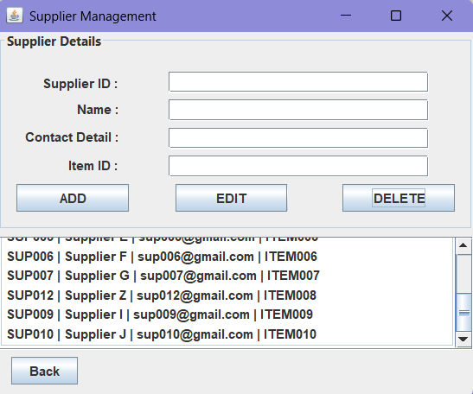

Figure 34: Delete Successfully

After clicking “Delete” button, Supplier K has successfully get remove from the list. Then, sales manager can click “Back” button and return to Home Page.

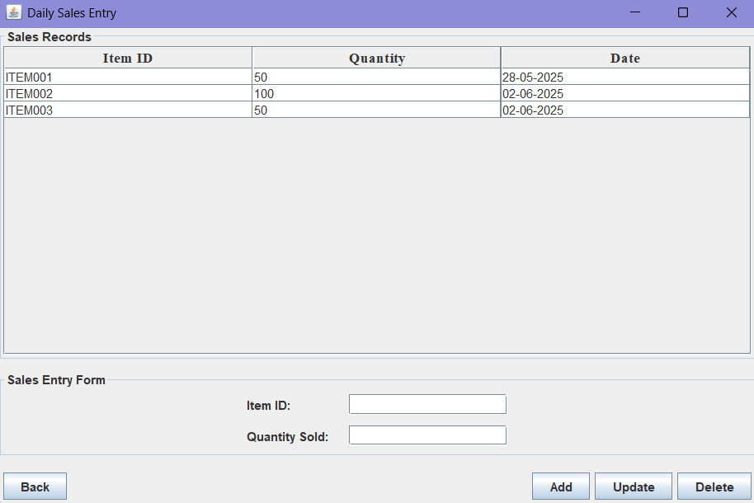

Figure 35: Daily Sales Entry Page

After clicking button “Sales Entry”, sales manager can see the daily sales records. The sales records shows as a table and it contains Item ID, Quantity and Date that key in the sales records. Sales manager can insert the Item ID and Quantity of the item they sold in the day. Sales manager also can add, upadate and delete the sales records.

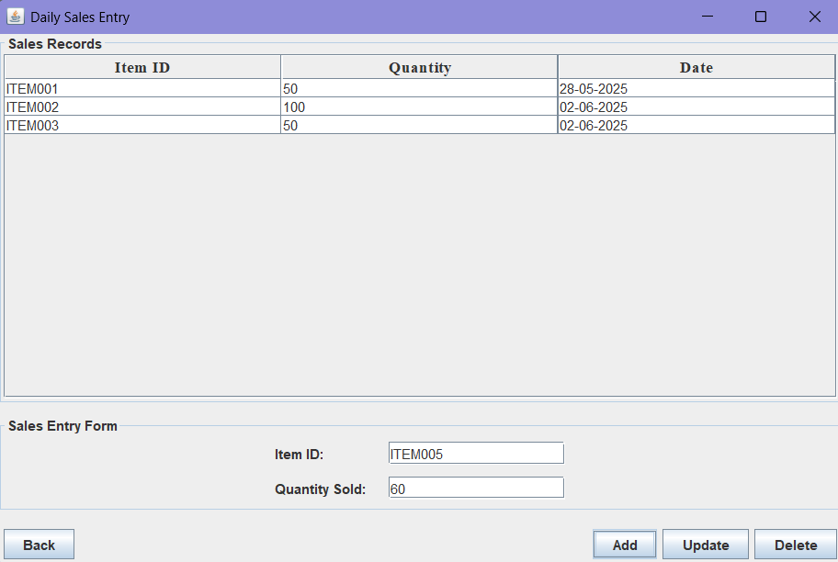

Figure 36: Insert New Record

Sales manager insert daily sales. Figure above shows ITEM008 has sold 60 quantity a days.

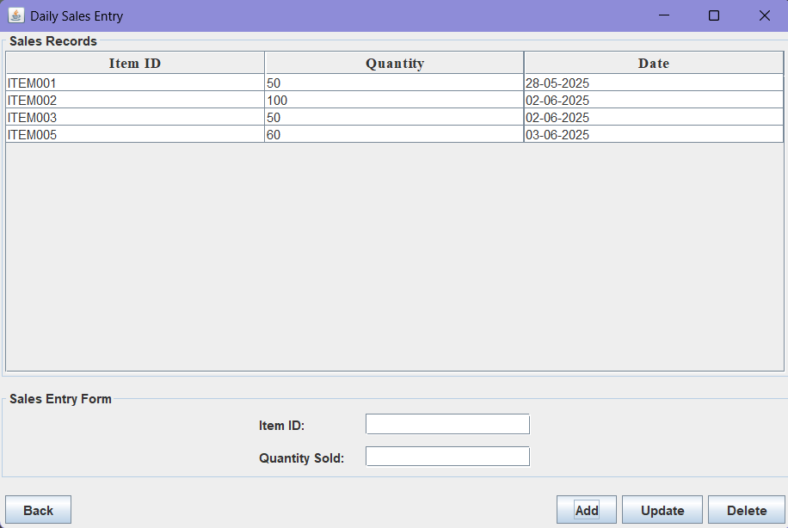

Figure 37: Record Successfully

Then sales manager click “Add” button. The “Sales Records” will record the new item’s daily sales.

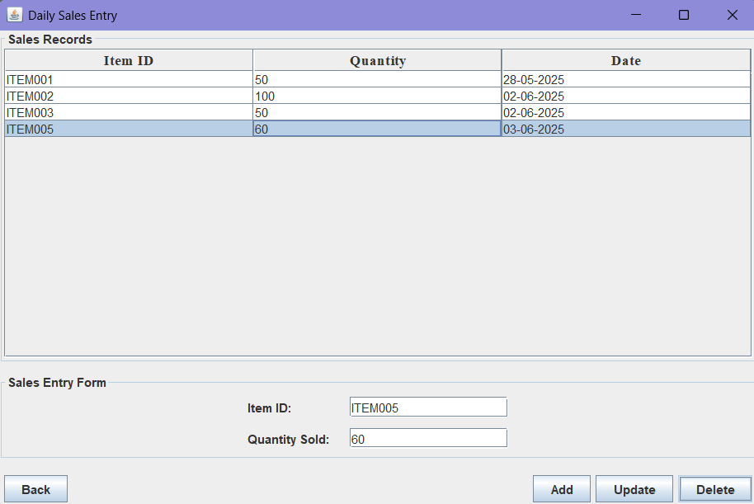

Figure 38: Delete Selected Row

Sales manager can click “Update” button to update the “Sales Records”. Sales manager also can select the row they want to delete and click “Delete” button.

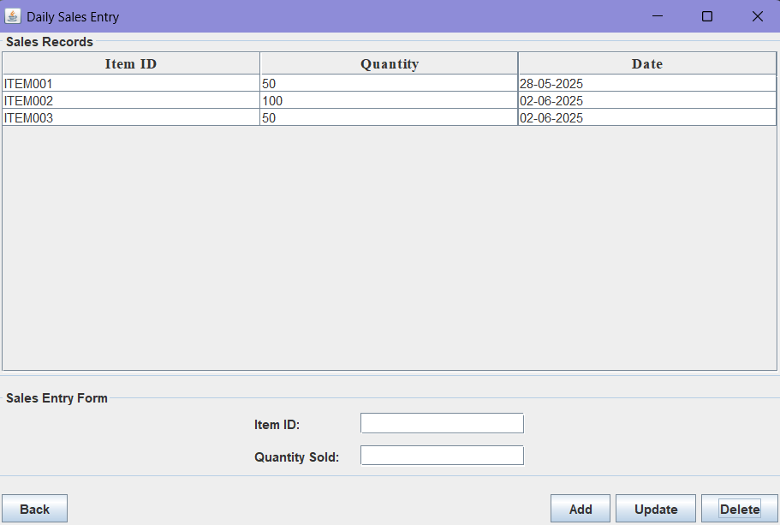

Figure 39: Delete Successfully

Then, the row that selected delete. After that, sales manager can click “Back” button to back to the Home Page.

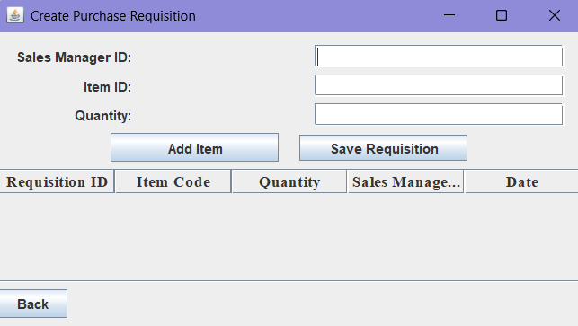

Figure 40: Create Purchase Requisition Page

After sales manager click button “Create Purchase Requisition”, sales manager can create purchases requisiton.

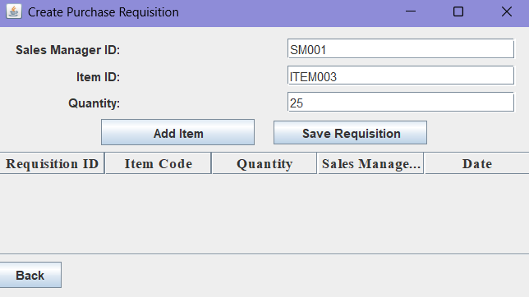

Figure 41: Insert New Requisition's Details

Sales manager can insert Sales Manager ID, purchase item’s Item ID and item purchase quantity to make purchase requisition.

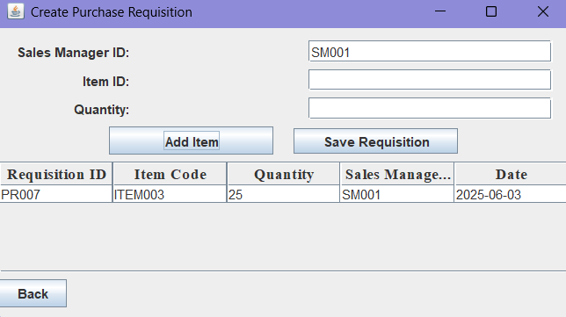

Figure 42: New Requisition Add Successfully

After sales manager click “Add Item”, the requisition details will show at the table below. System will auto generate Requisition ID and Date for the requisiton.

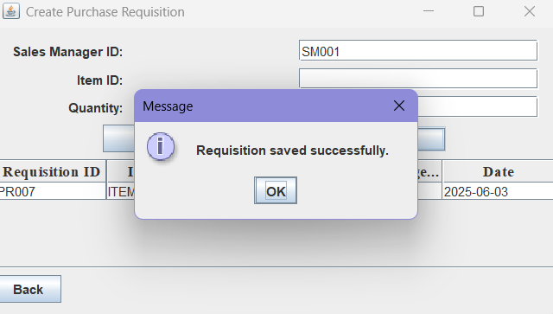

Figure 43: Save Requisition

Sales manager can check the requisition details at the table. If it is correct, sales manager can click “Save Requisiton” button to save the requisition. Then system will pop out a message says “Requisition saved successfully”. Sales manager can click “OK” button and back to Home Page.

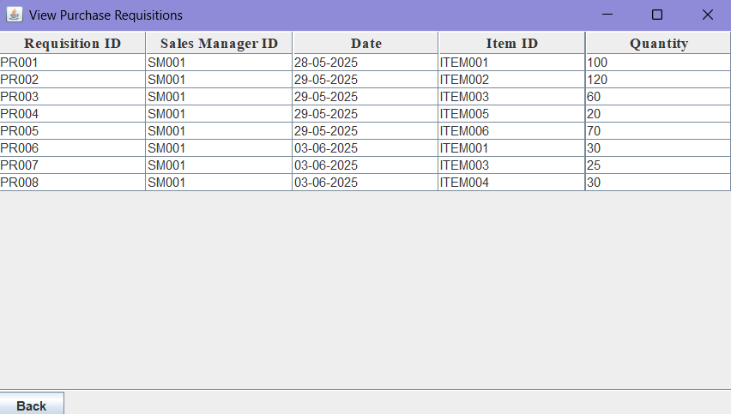

Figure 44: View Purchase Requisition Page

After sales manager click button “View Requisitions”, sales manager can and only can view the details of all purchase requisitions. Clicking “Back” button to back to Home Page.

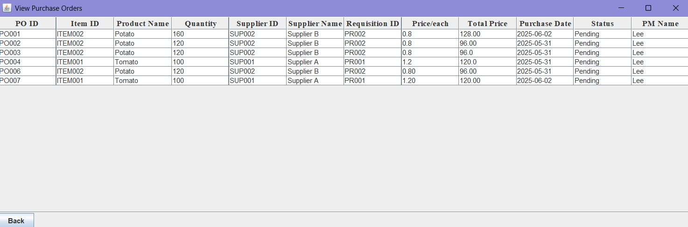

Figure 45: View Purchase Order Page

After sales manager click button “View Purchase Order”, sales manager can and only can view the details of all purchase orders. Clicking “Back” button to back to Home Page.

## 2.3 Purchase Manager

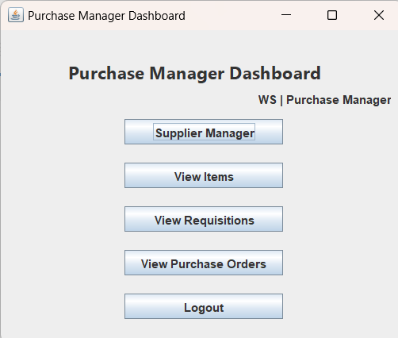

Figure 46: Main page (Dashboard)

This is the Purchase Manager “Dashboard” it will show when successful login as Purchase Manager role. The “Purchase Manager Dashboard” contains a list of action buttons which include View supplier, View Items, View requisitions and View purchase orders. Besides, it also contains “Logout >” button, user’s name and role.

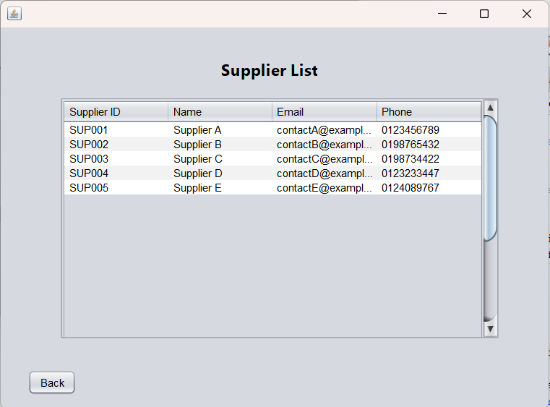

Figure 47: Supplier Viewer

After clicking “View Supplier” button, purchase manager can but cannot edit view supplier ID, supplier name, email address and phone number. User can click Back to quit this window.

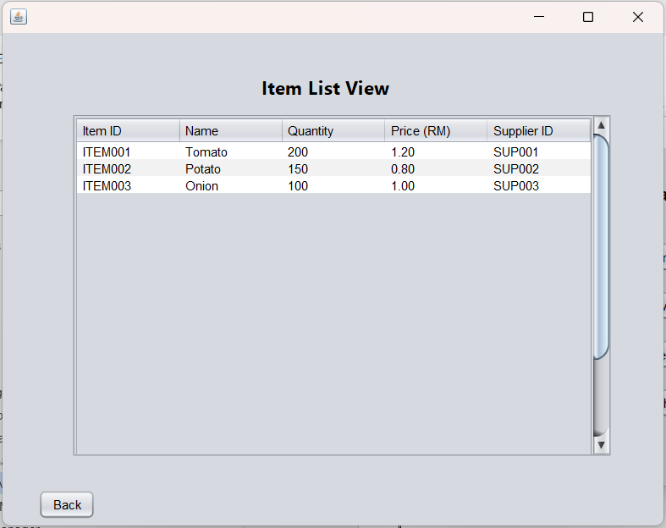

Figure 48: Item Viewer

After clicking “View Items” button, purchase manager can view but cannot edit item ID, item name, quantity of the item, item price and supplier who supply the item. User can click Back to quit this window.

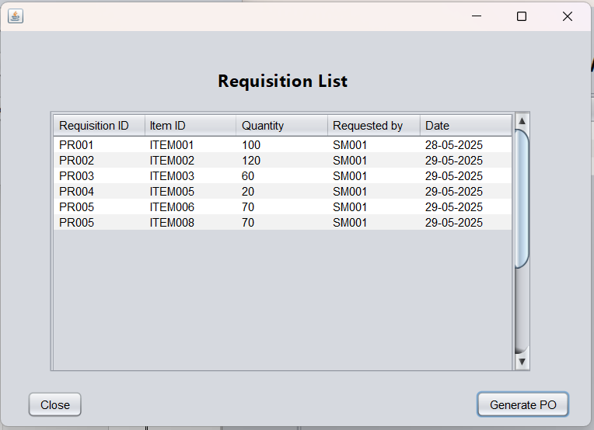

Figure 49: Requisition Viewer

After clicking “View Requisition” button, purchase manager can view but cannot edit requisition ID, item id, quantity of the item, sales manager ID who create the requisition and the date when requisition created. User can click Back to quit this window.

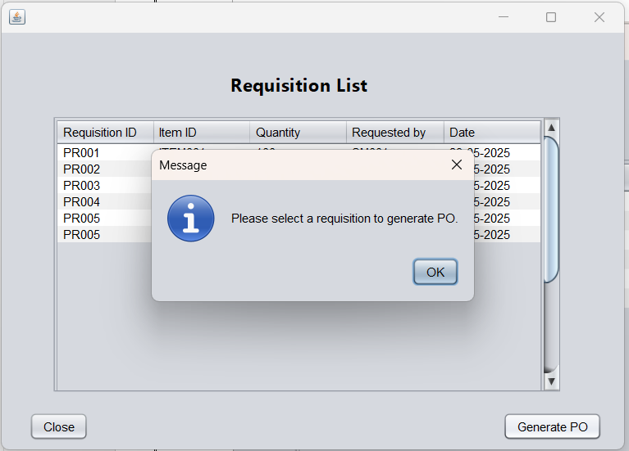

Figure 50: Error prompt Generate PO

If user did not select a requisition and click “Generate PO” Button, system will prompt an error message.

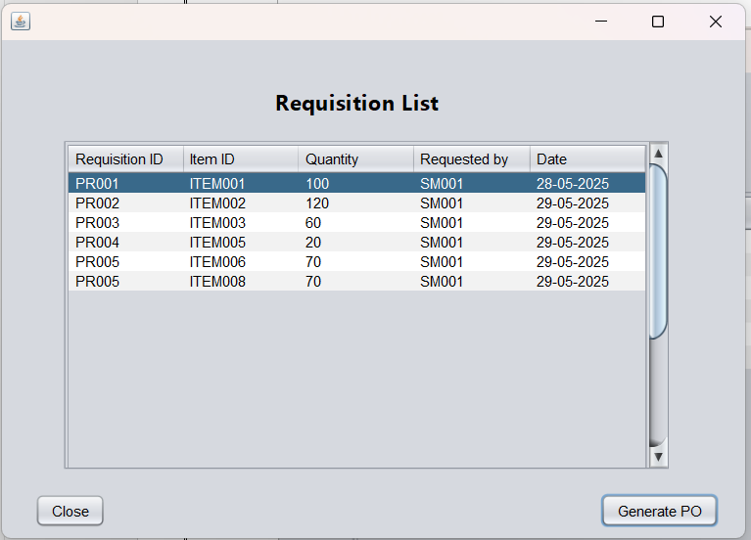

Figure 51: Choose requisition to generate PO

Select a requisition and click “Generate PO” or click “Close” return to Dashboard.

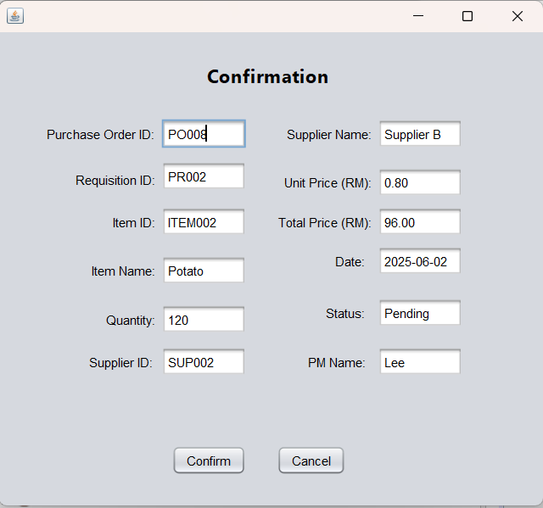

Figure 52: Confirmation page

A Confirmation from will show after clicking “Generate PO”, all details will show in this form. The system reads the items.txt and suppliers.txt files to fetch the item name, supplier ID, unit price, and supplier name based on the selected requisition. The system automatically generates a new PO ID, sets the status to "Pending", generate a date base on system time and calculate total price and add a purchase manager name base on the user who login. If “Confirm” button is clicked, it will save to purchase order file, else “Cancel” button is clicked, it will do nothing and return to requisition list.

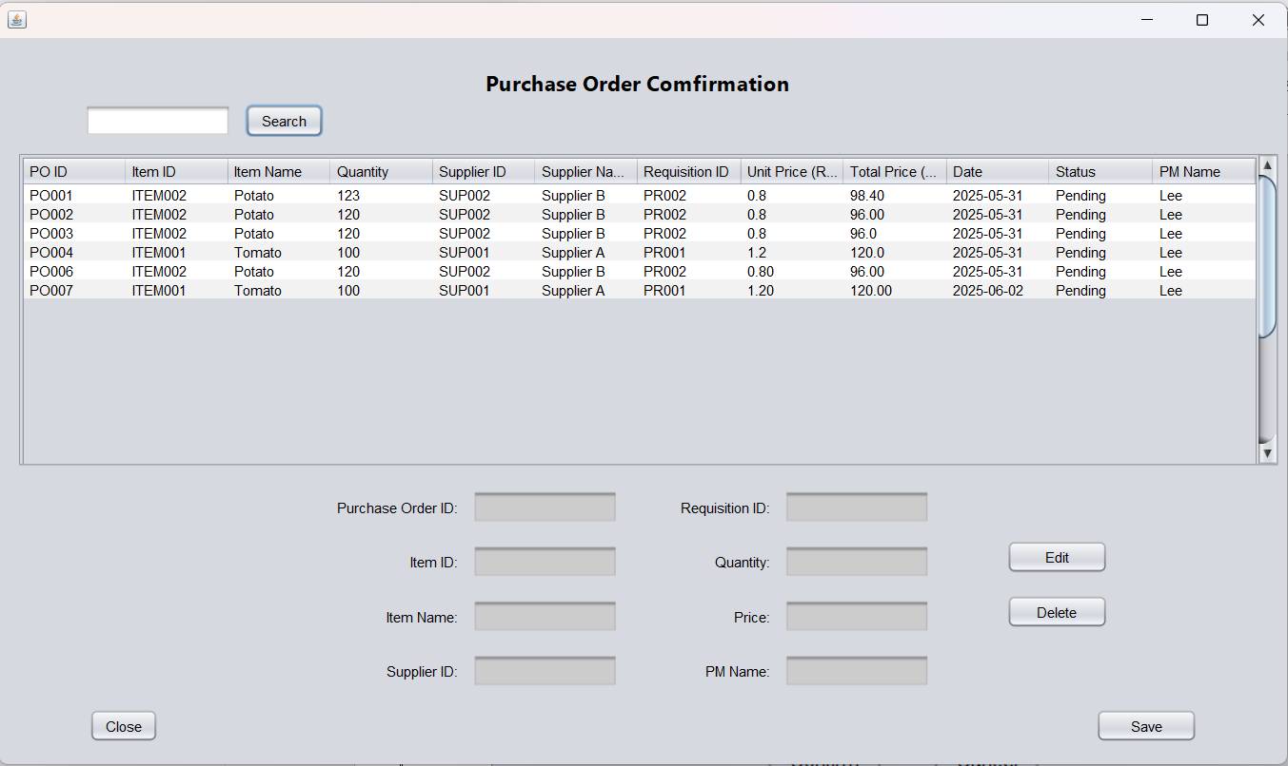

Figure 53: Purchase Order Viewer

Users click “View Purchase Order” in Dashboard to enter this page.

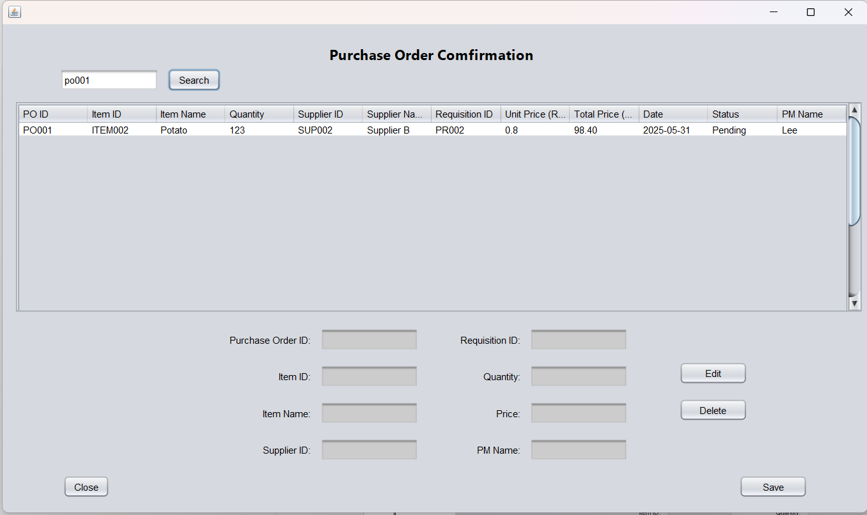

Figure 54: Search function

Users can search Purchase Order ID or status “rejected” to find the actual purchase order in the search bar. After entering purchase order id, click “Search” will show the details of the id. Click search without enter any word can refresh the table.

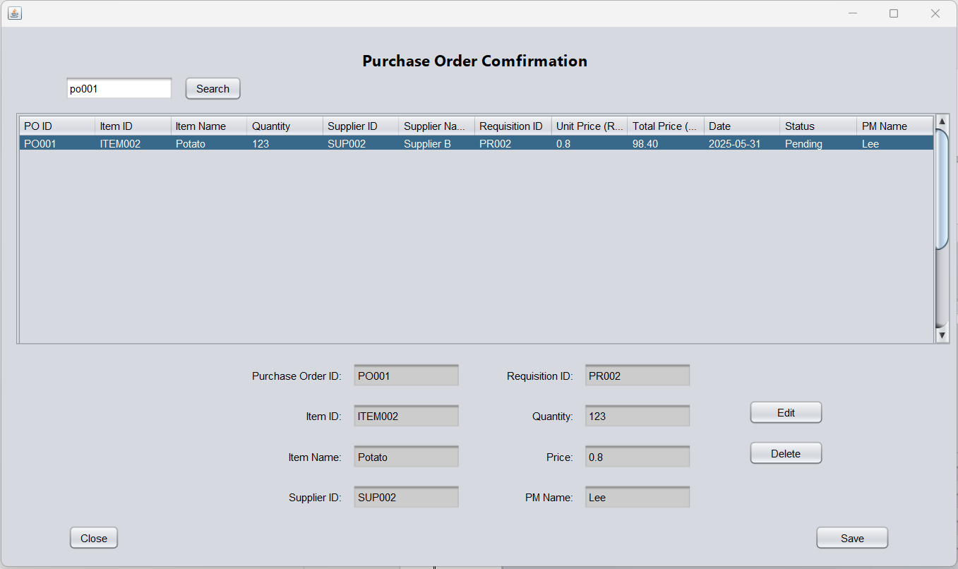

Figure 55: Choose row to edit

After that, we can select the row we want to edit and click “edit” button.

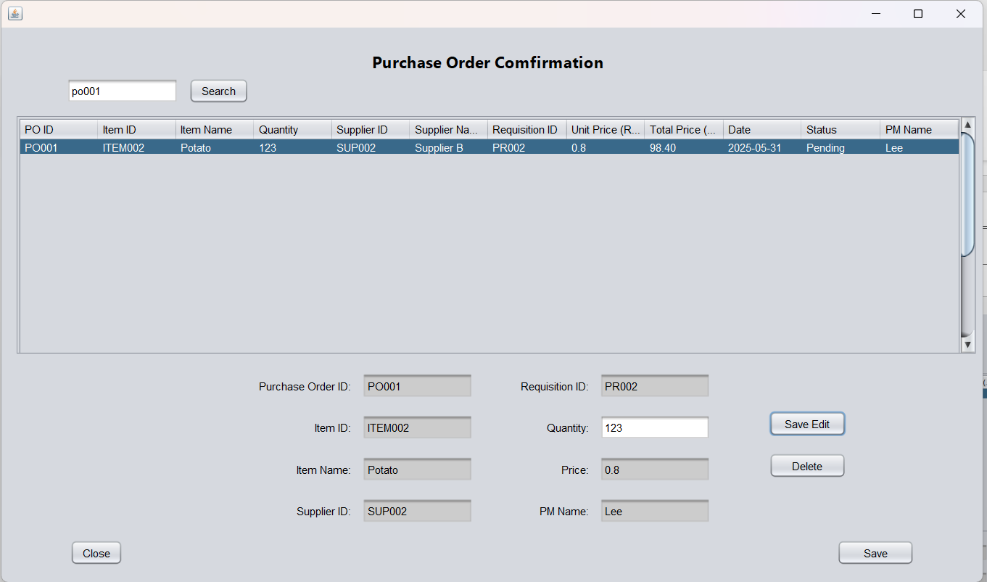

Figure 56: Edit Quantity

The text field will turn into white, that means it able to edit in the textfield. Purchase Manager will only allow to modify quantity because all detail will not be wrong except for financial is not satisfied with quantity and giving a rejection for the purchase order.

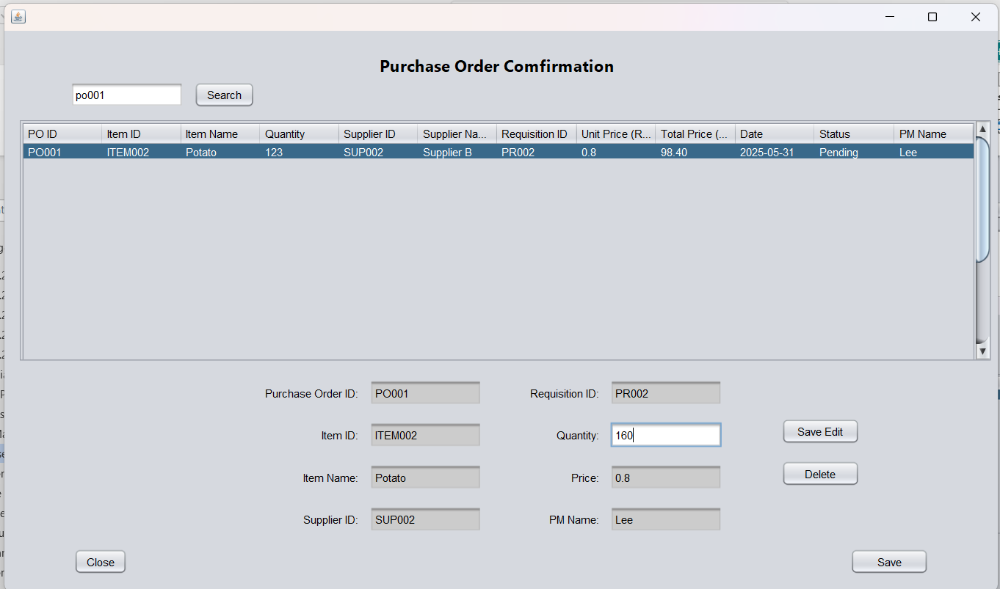

Figure 57: Save edit

After editing the quantity click “Save edit” to finish the edit.

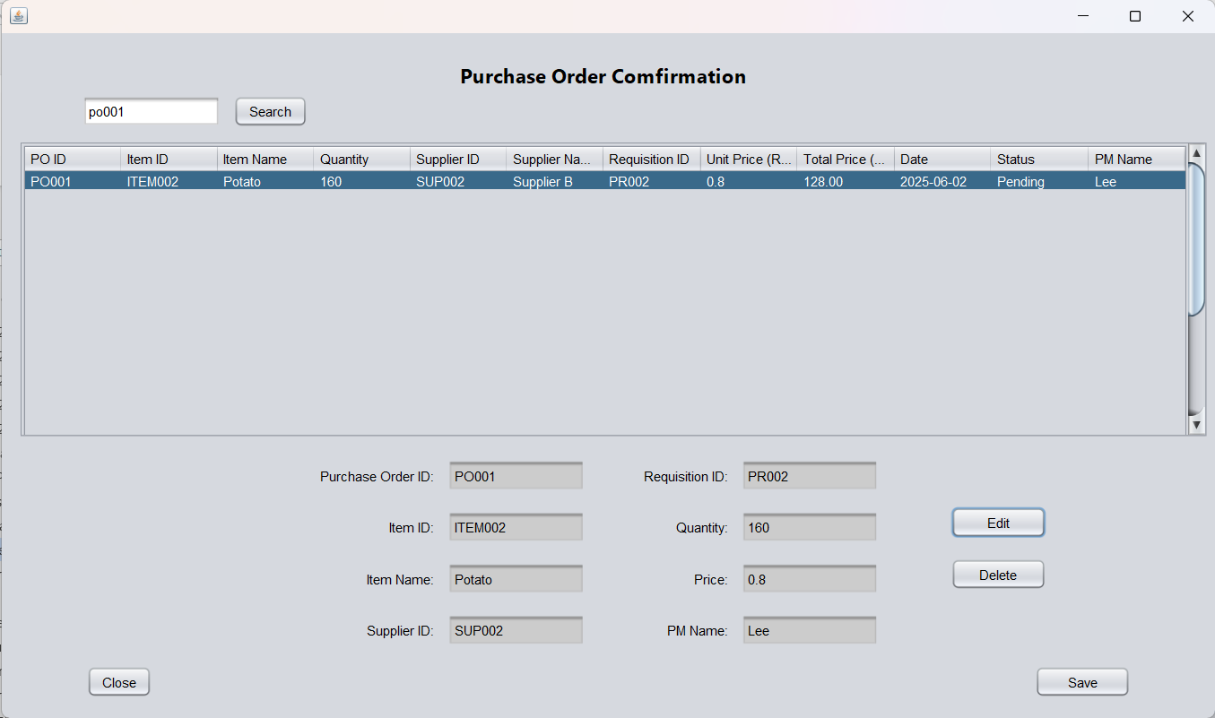

Figure 58: Details changing automatically

After clicking “Save edit” the quantiy, total price, date and status will change.

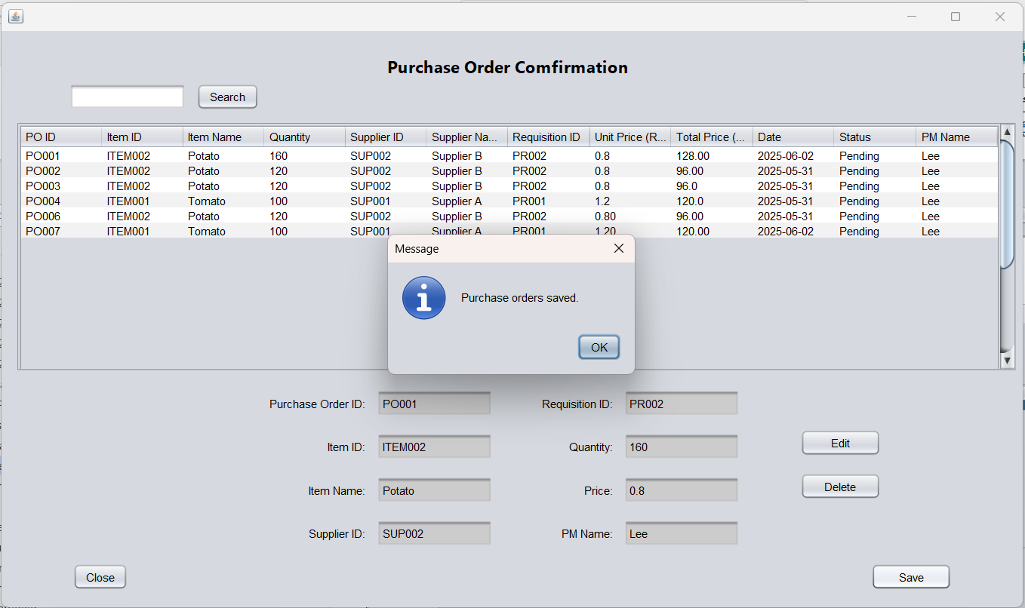

Figure 59: Save to text file

Lastly, user need to save the modification of purchase order, user click “Save” and system will prompt a message to let user know modification is saved successfully.

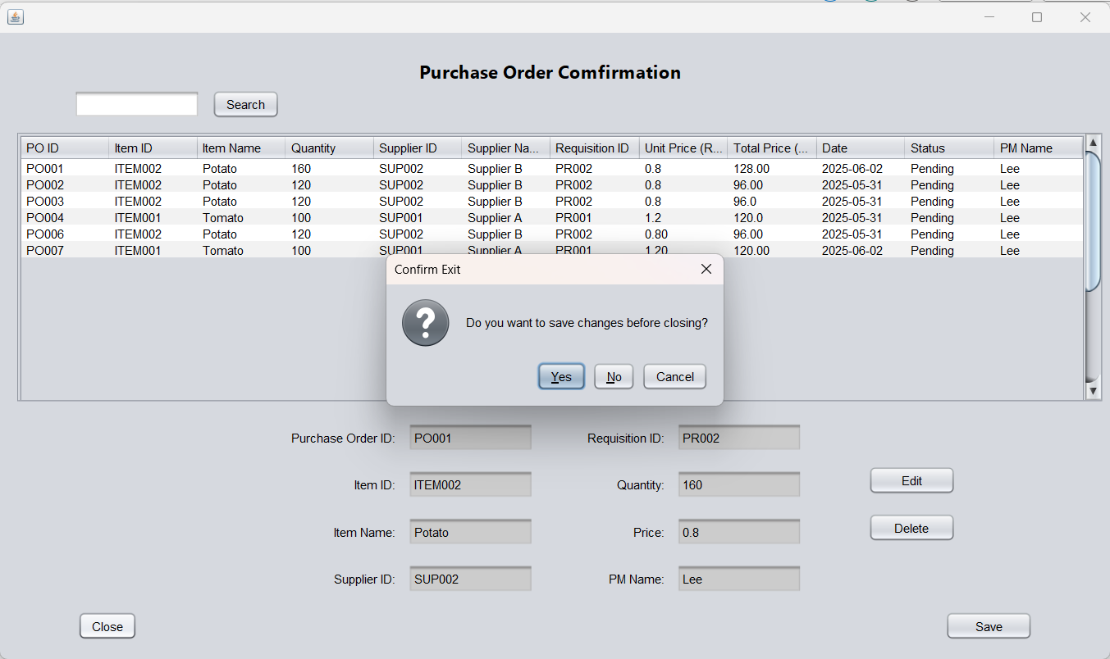

Figure 60: Save Confirmation

When user click close, a “confirm exit" message will prompt, user can choose “yes” or “no” for choosing whether need to save changes, if click “Cancel” it will do nothing and return to purchase order list. This prevents user exit without saving.

## 2.4 Inventory Manager

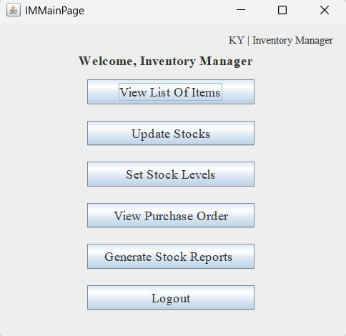

Figure 61: Main page for Inventory Manager

This is the main page of the Inventory Manager, which is displayed after logging into the Inventory Manager. Here the Inventory Manager can select View List of Items, Update Stocks, Set Stock Levels, View Purchase Reports, Generate Stock Reports and Logout operations.

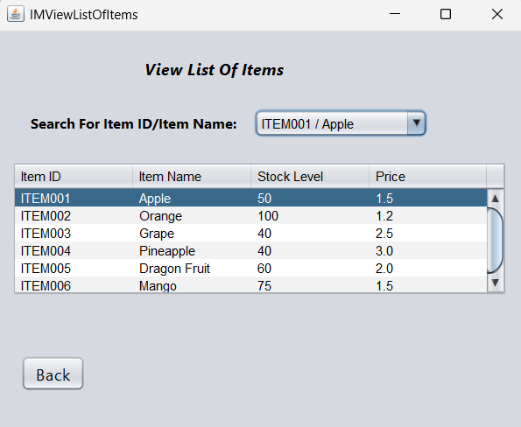

Figure 62: View List of Items for Inventory Manager

After clicking the button, the manager will be taken to the "View List of Items" page, which will display a table, a combo box and a button “Back”. The table displays the items details read from item text file. In addition, when the inventory manager views the table, table cannot be edited and is for viewing only. Moreover, user can directly select the Item ID/Item Name to view from the combo box, and the matching rows will be highlighted in the table. Lastly, user click button “Button” to return to the main page.

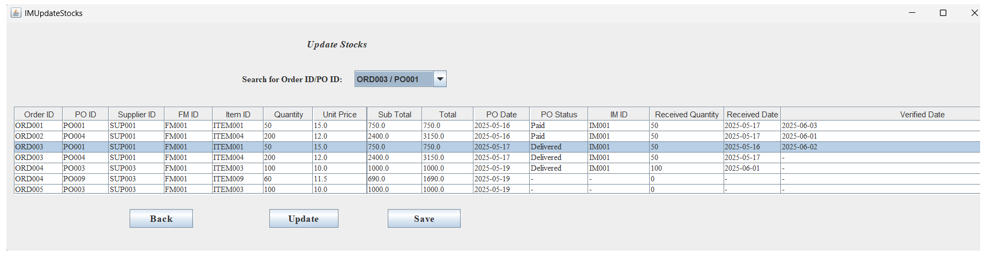

Figure 63: Update Stocks for Inventory Manager

After clicking the button, the manager will be taken to the "Update Stocks" page, which will display a table, a combo box, button “Back”, button “Update” and button “Save”. The table displays the order details read from Order text file. In addition, when the inventory manager views the table, table cannot be edited and is for viewing only. In addition, user can directly select the Order ID/PO ID to view from the combo box, and the matching rows will be highlighted in the table. Lastly, user click button “Button” to return to the main page.

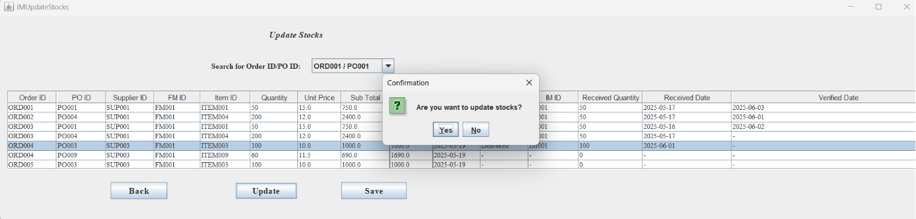

Figure 64: Update Stocks for Inventory Manager

When manager click button “Update” will pop up a confirm dialog “Are you want to update stock?”, then show button “Yes” and button “No”.

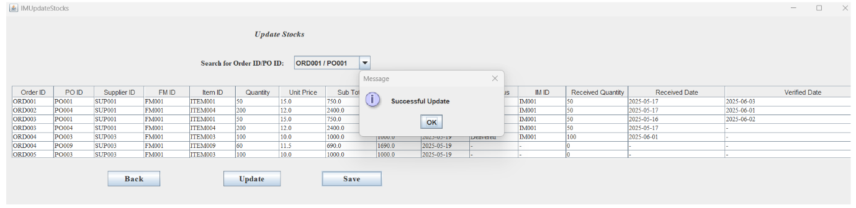

Figure 65: Update Stocks for Inventory Manager

After click button “Yes” user can update table. After edit the table, click button “Save” then that edit table data also will save in Order text file and show a message “Successful Update”.

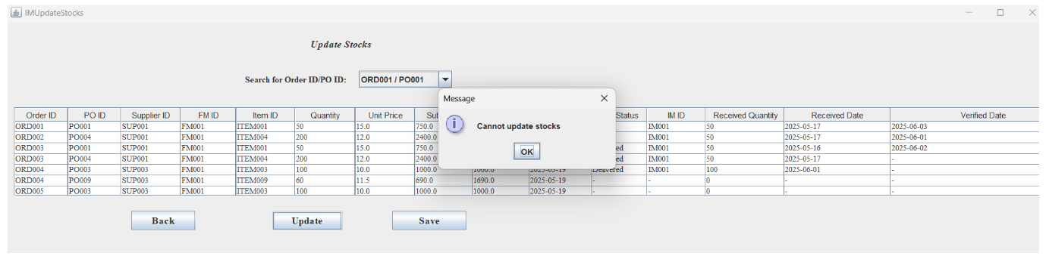

Figure 66: Update Stocks for Inventory Manager

Click button “No” will show a message “Cannot update stocks” so user cannot be able to update stocks.

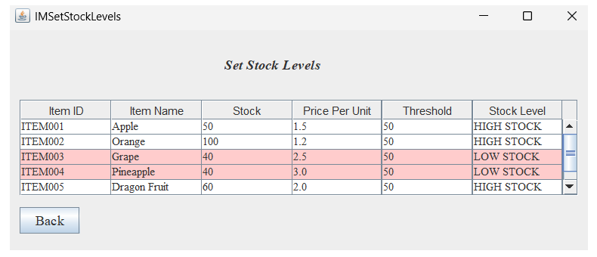

Figure 67: Set Stock Levels for Inventory Manager

After clicking the button, the manager will be taken to the "Set Stock Levels" page, which will display a table and a button “Back”, The table displays the item details read from item text file. Lastly, user click button “Button” to return to the main page.

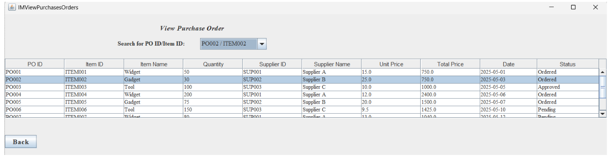

Figure 68: View Purchase Order for Inventory Manager

After clicking the button, the manager will be taken to the "View Purchase Order" page, which will display a table, a combo box and a button “Back”. The table displays the Purchase Order details read from PO text file. In addition, user can directly select the PO ID/Item ID to view from the combo box, and the matching rows will be highlighted in the table. Lastly, user click button “Button” to return to the main page.

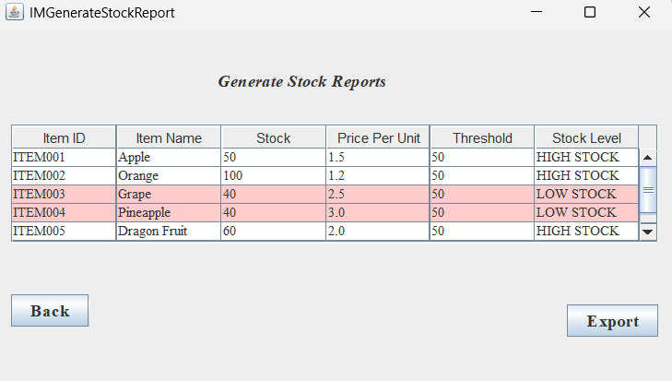

Figure 69: Generate Stock Report for Inventory Manager

After clicking the button, the manager will be taken to the "Generate Stock Reports" page, which will display a table, button “Back” and button “Export”. The table displays the item details read item text file. In addition, user click button “Button” to return to the main page. Lastly, user can click button “Export” so the table will export in CSV.

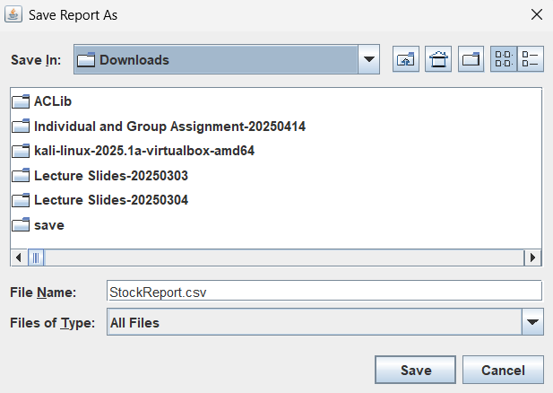

Figure 70: Generate Stock Report for Inventory Manager

User can select save in Downloads.

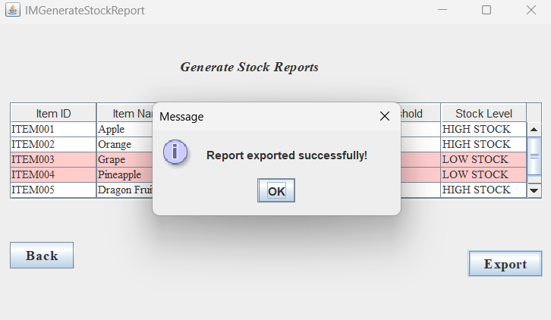

Figure 71: Generate Stock Report for Inventory Manager

Then will pop up a message show “Report exported successfully!”.

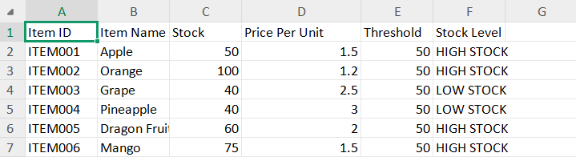

Figure 72: Generate Stock Report for Inventory Manager

Lastly table will show in this CSV.

## 2.5 Finance Manager

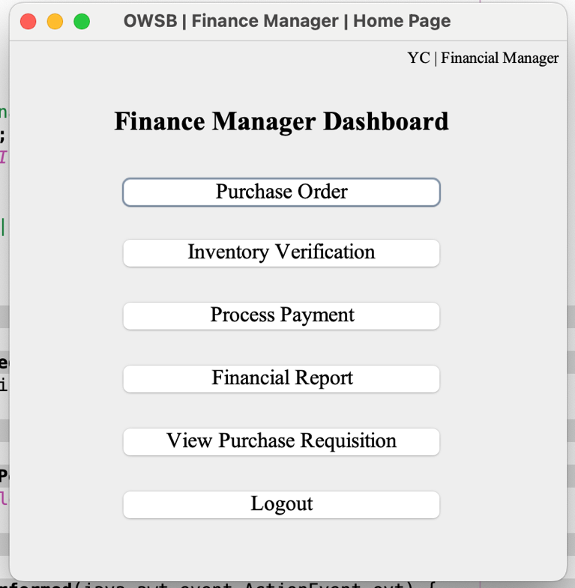

Figure 73: Finance Manager Home Page

This is the Home Page of Finance Manager which will be shown after login as Finance Manager. There is list of action which Finance Manager can perform, Purchase Order, Inventory Verification, Process Payment, Financial Report, View Purchase Requisition and Logout.

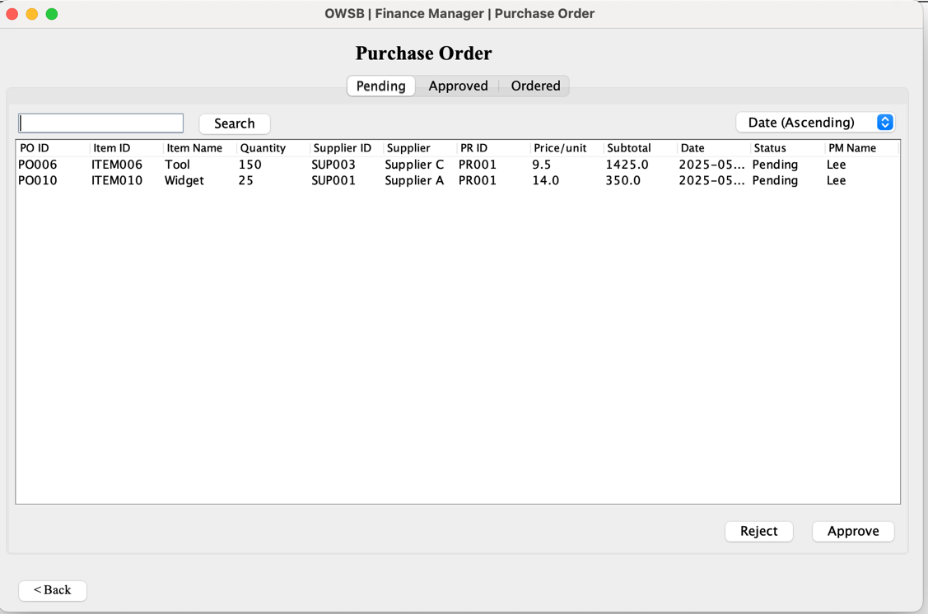

Figure 74: Purchase Order

In Purchase Order, there are three tabs of table showing Purchase Order by status Pending, Approved, Ordered.

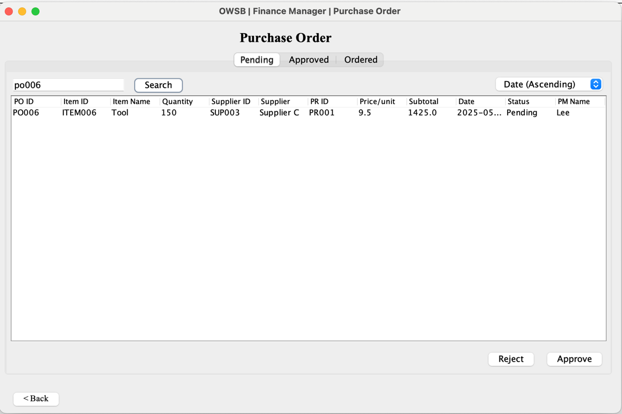

Figure 75: Purchase Order with search function

User can also use the “Search “button to search Purchase Order by its ID.

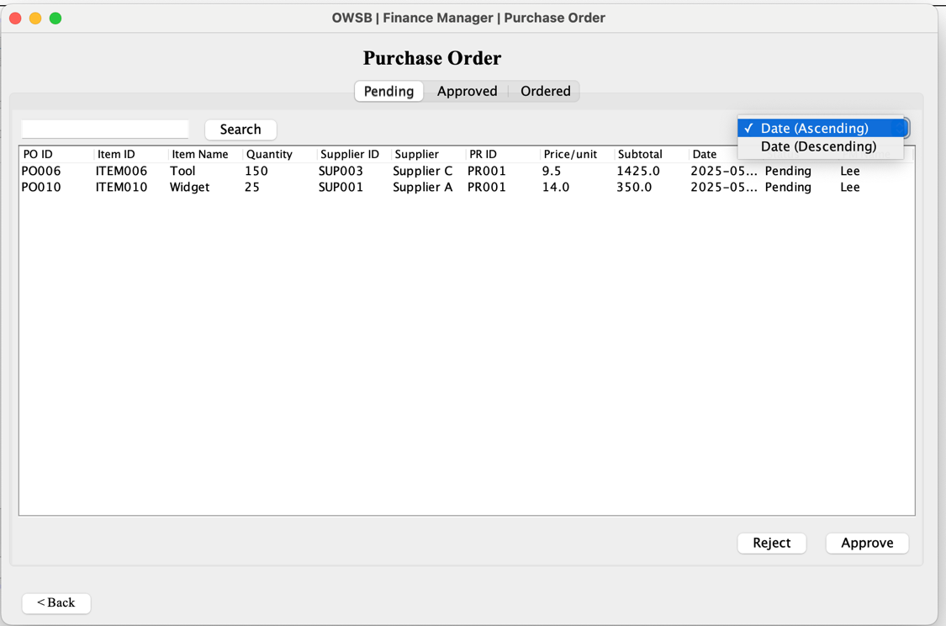

Figure 76: Purchase Order with sort function

Not only that, a sort of combo box with selection of Date (Ascending) and Date (Descending) is created for Finance Manager to have a better using experience.



Figure 77: Purchase Order (Pending)

In Pending, user can select Pending Purchase Order to make it Approved or Rejected. If it is rejected, it will prompt an action success message box and notice the Purchase Manager, if it is Approved, it will prompt an action success message box and show in Approved tab.

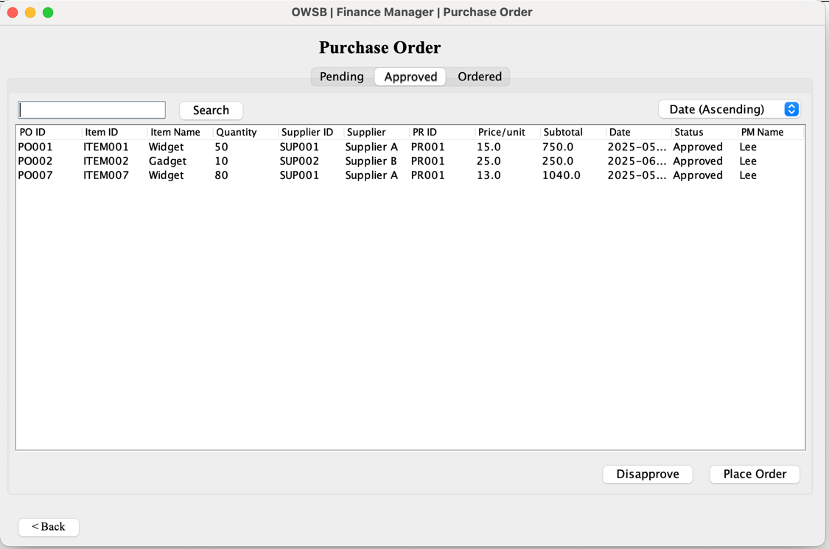

Figure 78: Purchase Order (Approved)

In the Approved tab, Finance Manager can select any Purchase Order that comes from the same Supplier to Place Order. Not only that, Finance Manager also can Disapprove the Purchase Order, which change the Purchase Order status to “Pending”.

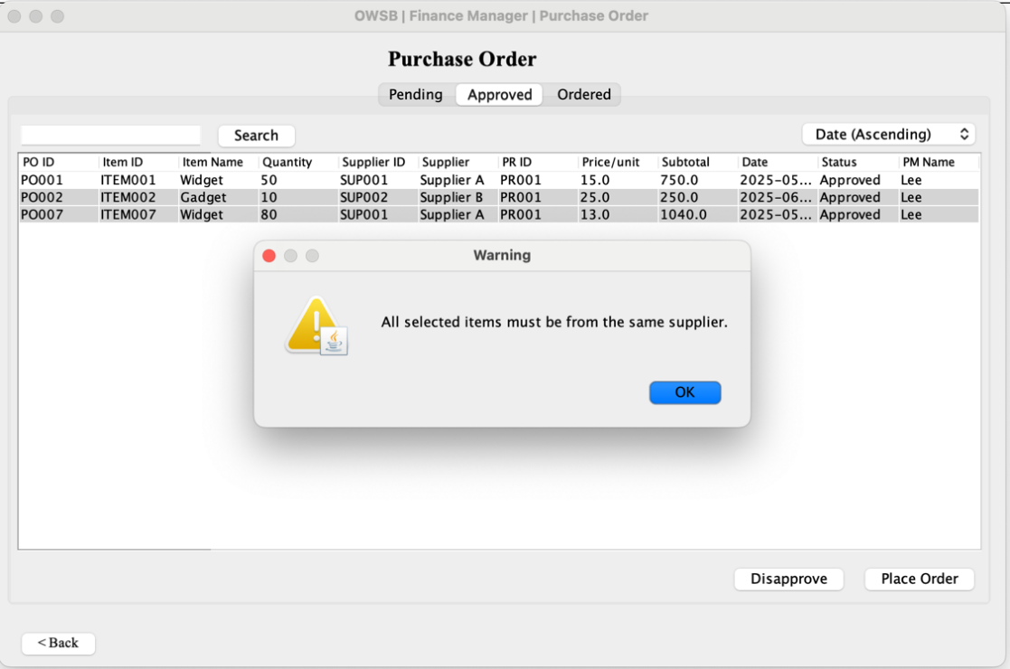

Figure 79: Place Order Error

If Finance Manager selected item from different supplier, a warning message box will be prompt.

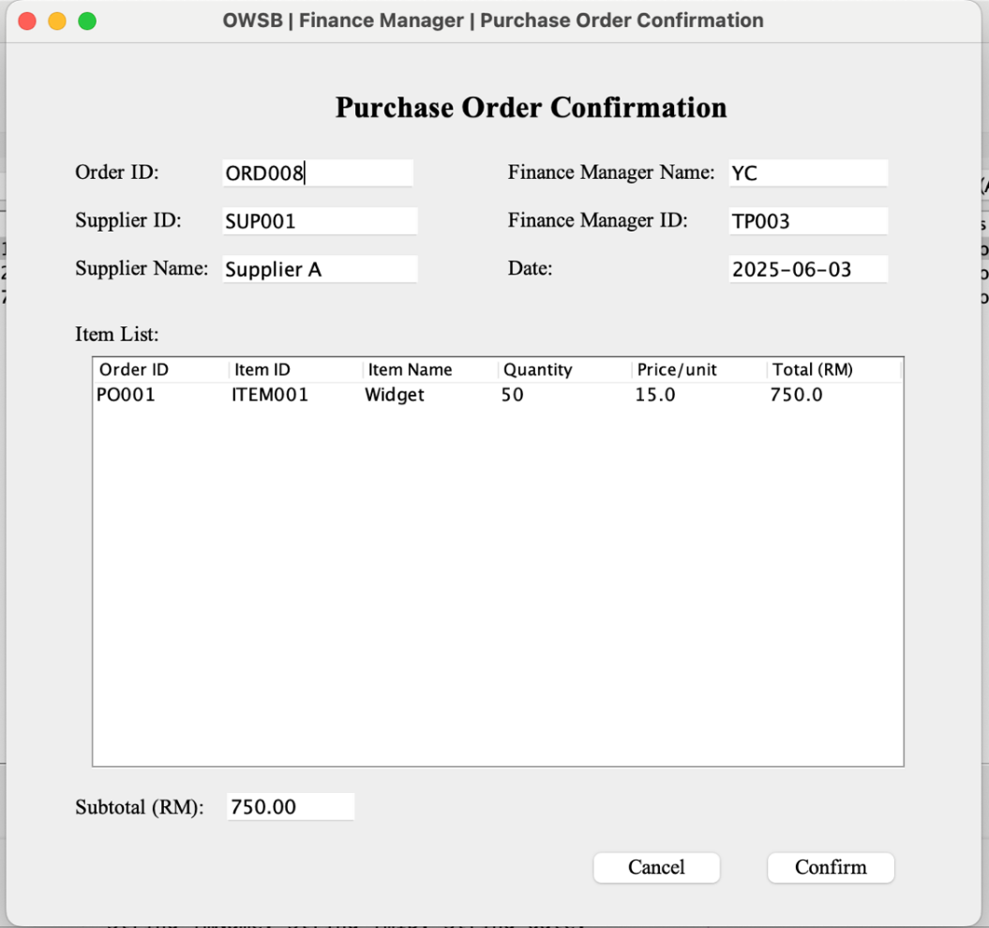

Figure 80: Place Order Confirmation

If the Finance Manger success Place Order, a Purchase Order Confirmation page will be prompt. Details of the order will be shown. If the Finance Manager press button “Confirm”, the order will be made and written in the Order.txt and a success message box will be shown. If the Finance Manager press button “Cancel”, it will return to the Purchase Order page.

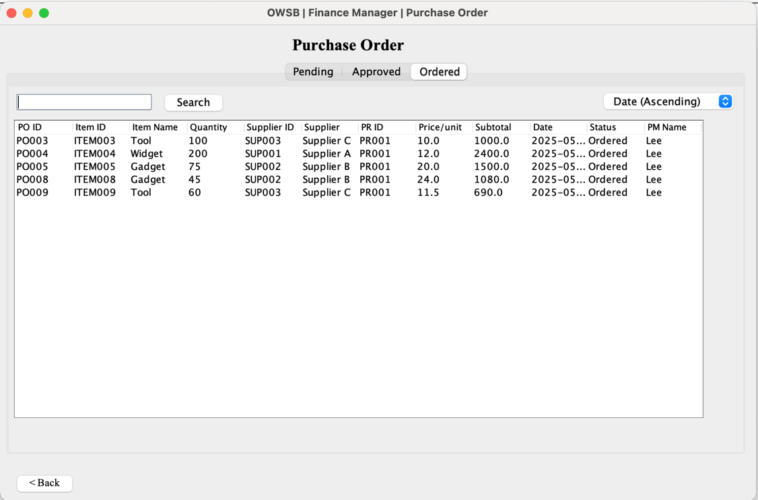

Figure 81: Purchase Order (Ordered)

Besides that, in the Purchase Order page, Finance Manager can also view Purchase Order that had made order.

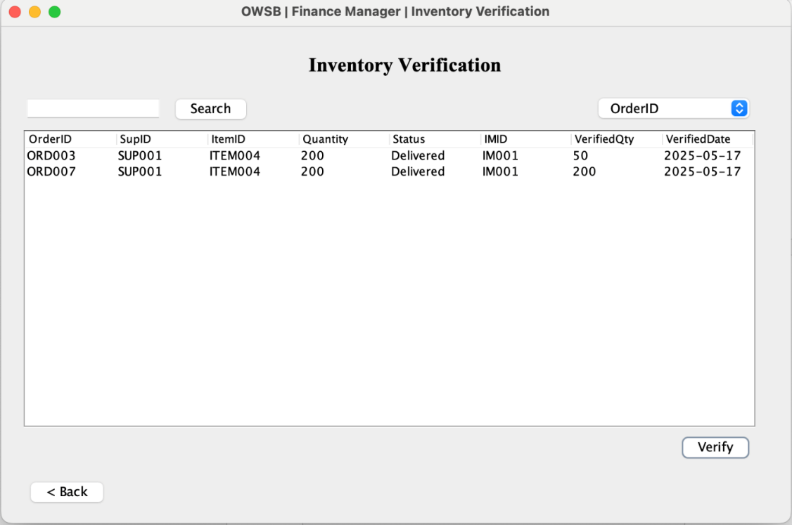

Figure 82: Inventory Verification

Next, in Inventory Verification, Finance Manager will be shown a table with item been received from the Inventory Manager. Finance Manager should verify the received item quantity which match the quantity that ordered.

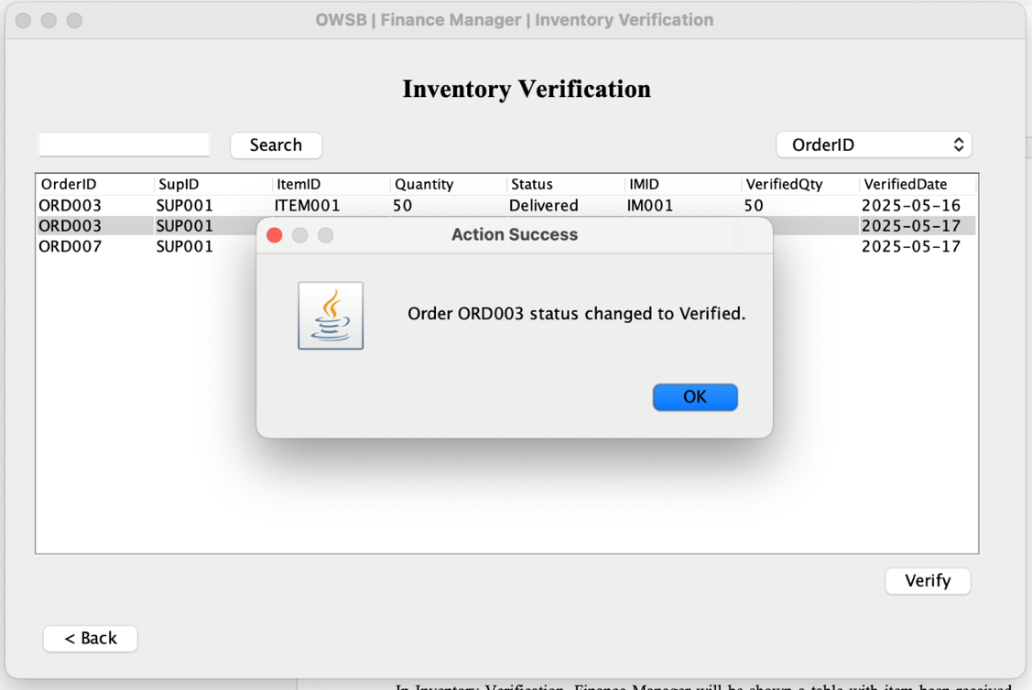

Figure 83: Success verify inventory

If the item been verified, it will prompt an Action Success message box. And the order status will be changed to “Verified”.

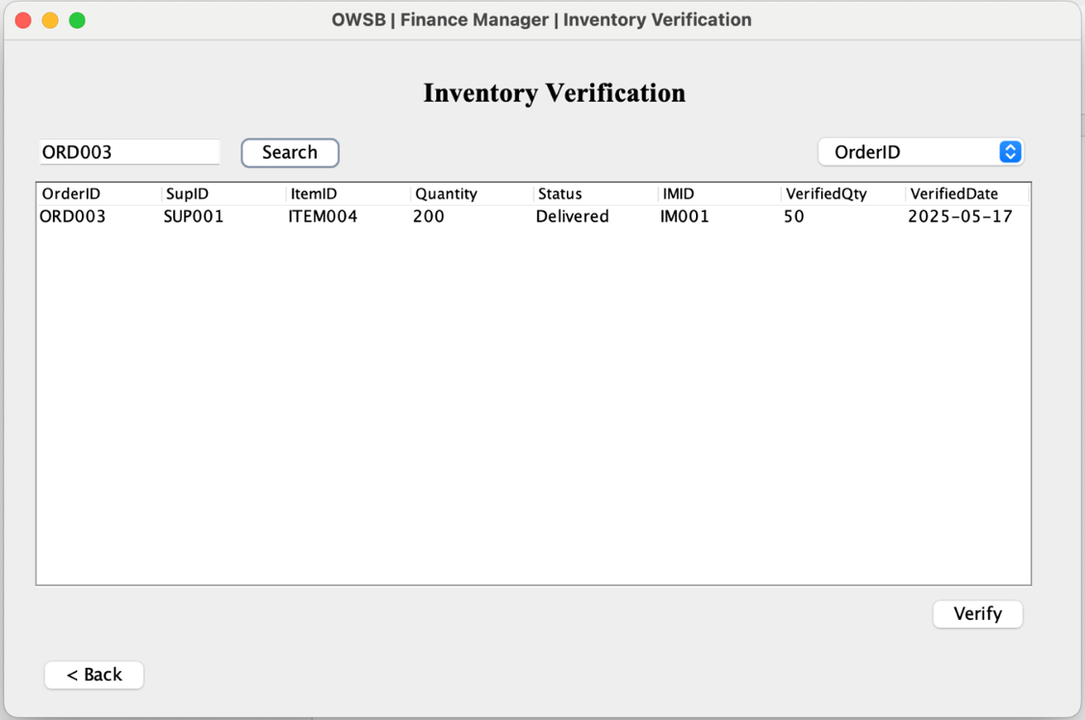

Figure 84: Inventory Verification with search and sort function

Same as Purchase Order, Finance Manager can search inventory by using Order ID and sort by Order ID, Date (Ascending) and Date (Descending).

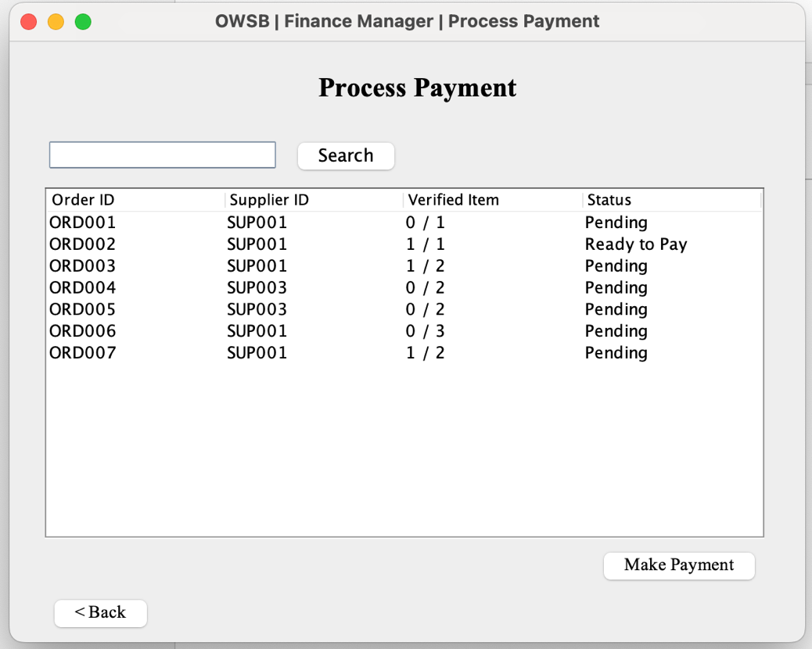

Figure 85: Process Payment

In the Process Payment page, a table will show all Order ID and number of items been verified. If all item in the order has been verified, the status will show “Ready to Pay”, else it will show “Pending”. Same, it can be search by using Order ID. Finance Manager can select the order that “Ready be pay” and press “Make Payment” button.

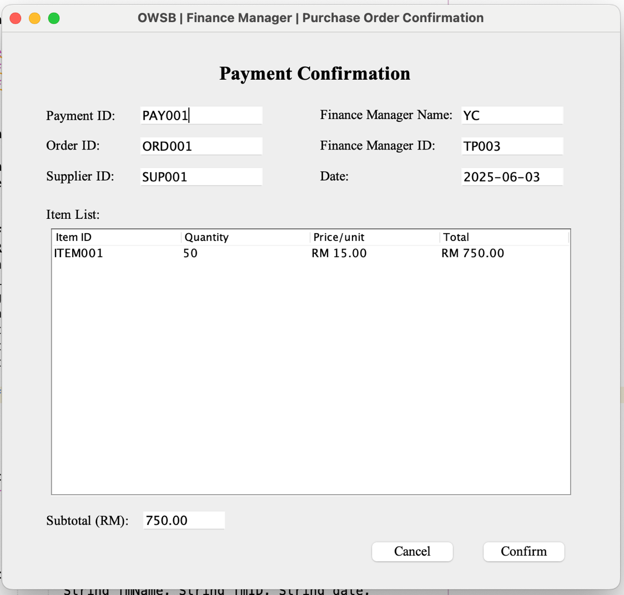

Figure 86: Payment Confirmation

After selecting “Make Payment” button, a payment confirmation page will be prompt and show details of the payment. Once the Finance Manager confirm the payment, a success message box will be prompt. If Finance Manager cancel the payment, it will return to the Process Payment page.

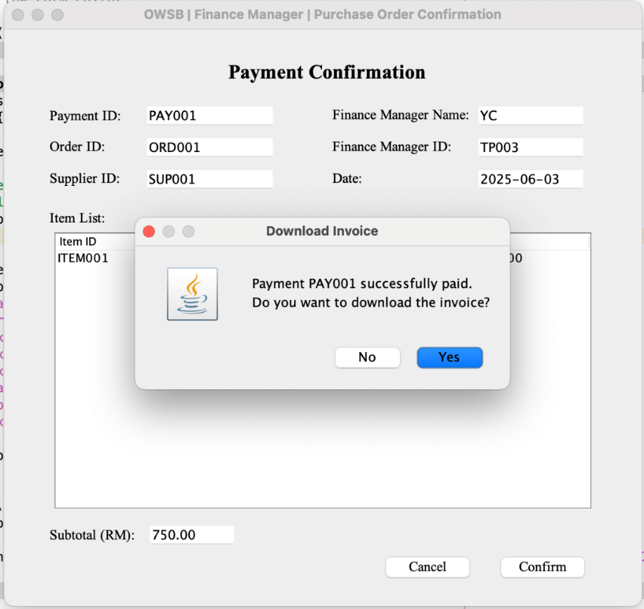

Figure 87: Download invoice

After confirming the payment, a message box will be prompted to ask Finance Manager to download the invoice.

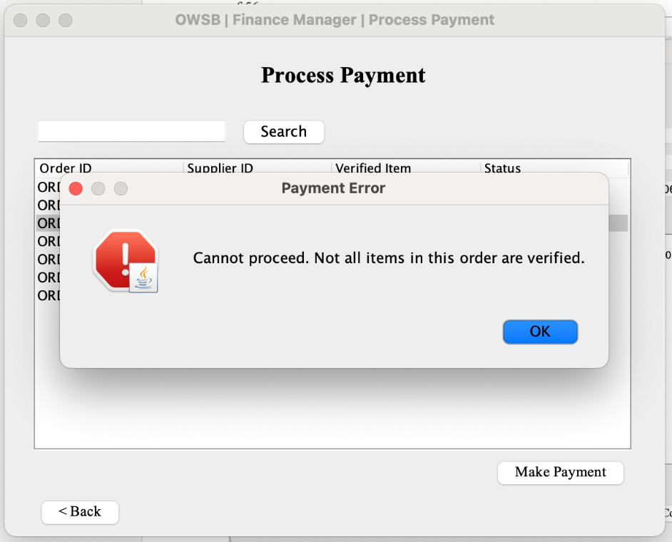

Figure 88: Error of selecting order that has not completed

However, if Finance Manager select order that haven’t been all delivered, a error message box will be prompt.

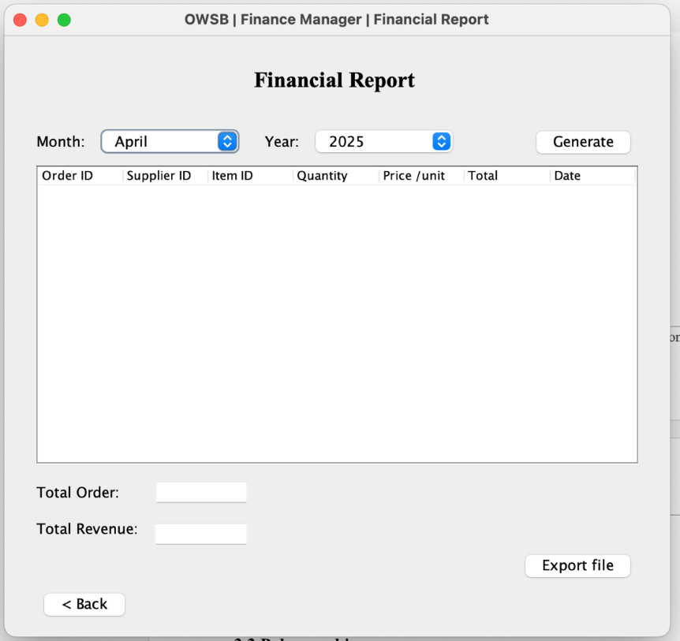

Figure 89: Financial Report

For Finance Report, Finance Manager can select the month and year of report that want to generate.

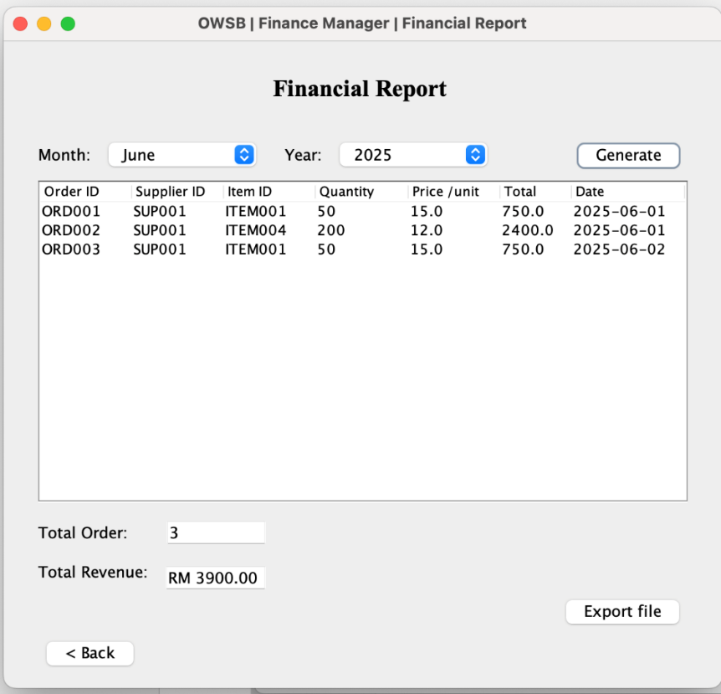

Figure 90: Generate Financial Report

The table will show all order details that been done by the selected date. Moreover, the system will prompt the total order and total revenue for Finance Manager.

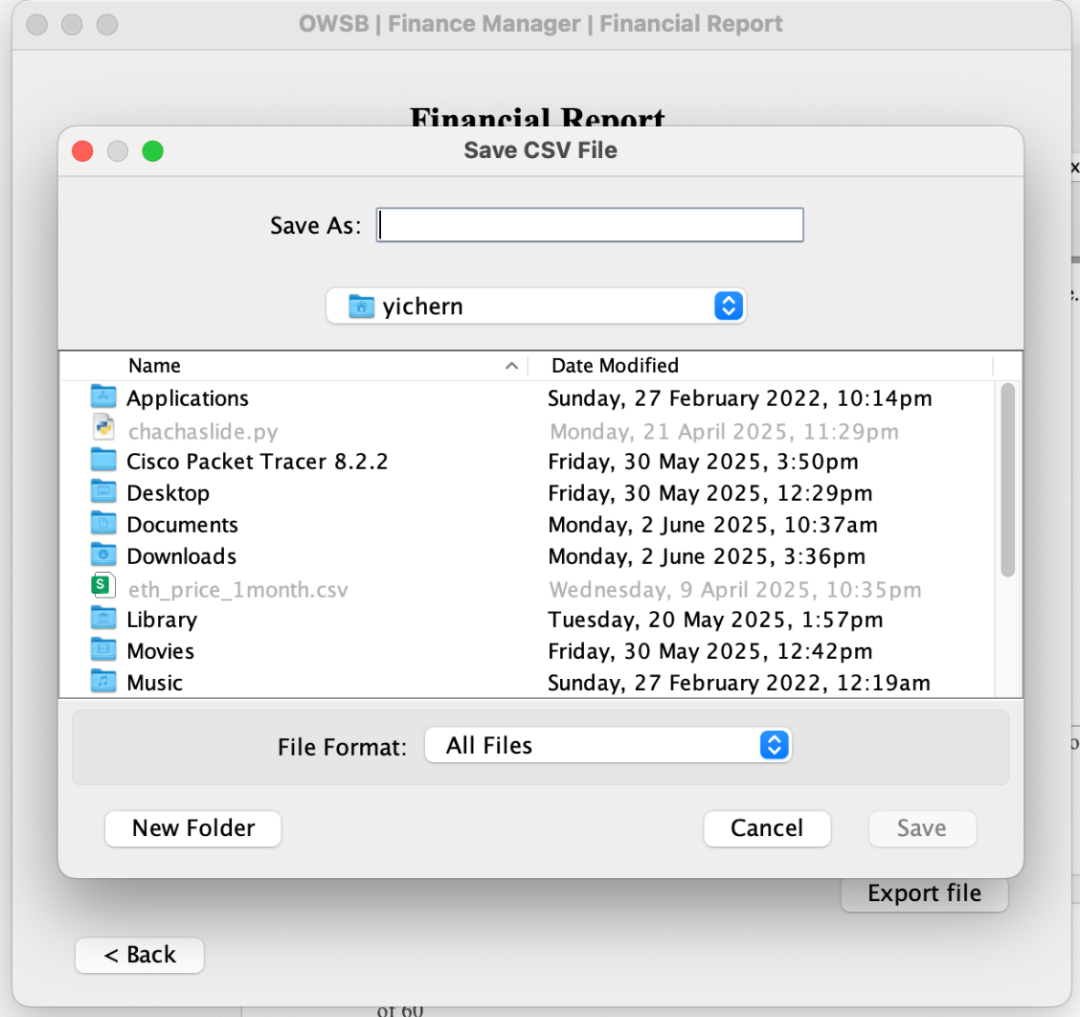

Figure 91: Export Financial Report

Finance manager can choose to export the file as CSV format. The system will ask location to save the file.

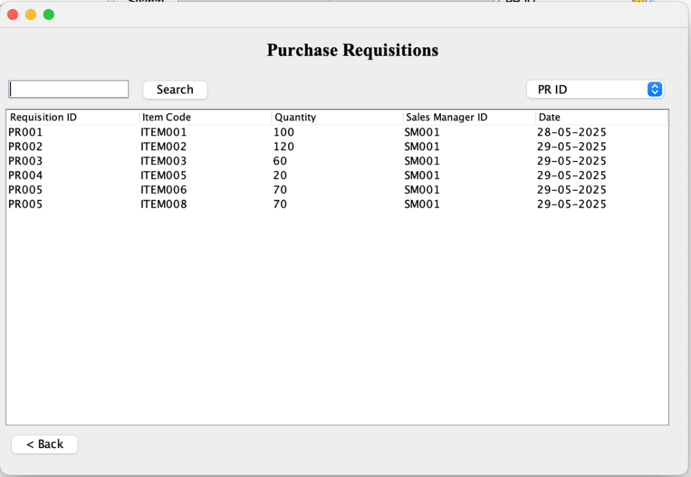

Figure 92: View Purchase Requisition

In View Purchase Requisitions page, Finance Manager is shown a list of Purchase Requisition that made by Sales Manager in a table. Same as Purchase Order page, the table can be search by Purchase Requisition ID and sort by Requisition ID and Date.

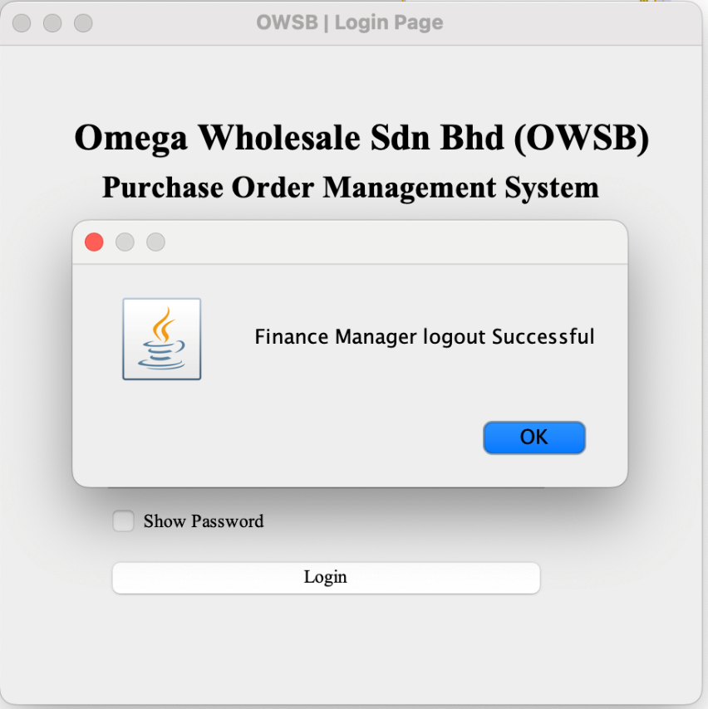

Figure 93: Logout

Last but not least, the Logout button will return the Login Page and prompt a logout success messagebox.

# 3.0 Object Oriented Concepts

Object-Oriented Programming (OOP) is a programming paradigm that organizes software design around the concept of "objects." The goal of OOP is to create modular, reusable, and maintainable code, allowing developers to model complicated systems more efficiently. OOP reflects how elements interact in the real world by grouping data and activity into objects, making it easier to express and manage relationships, interactions, and responsibilities inside a system. The foundation of OOP is built on four main principles, Encapsulation, Inheritance, Abstraction and Polymorphism.

For example, in OOP, a class acts as a blueprint for building objects, which can subsequently be used to call methods and access properties, allowing for interaction between different portions of a program. Consider a simple class Order that defines attributes orderID, poID and so on and method that perform actions such as readOrderFile(). By creating an instance of this class, a program can manipulate the data through the object’s method.

**Order class:**

* We use key word “class” to create a class.
* Attributes will be define at the following field with the access modifier, data type and name of variable

Class

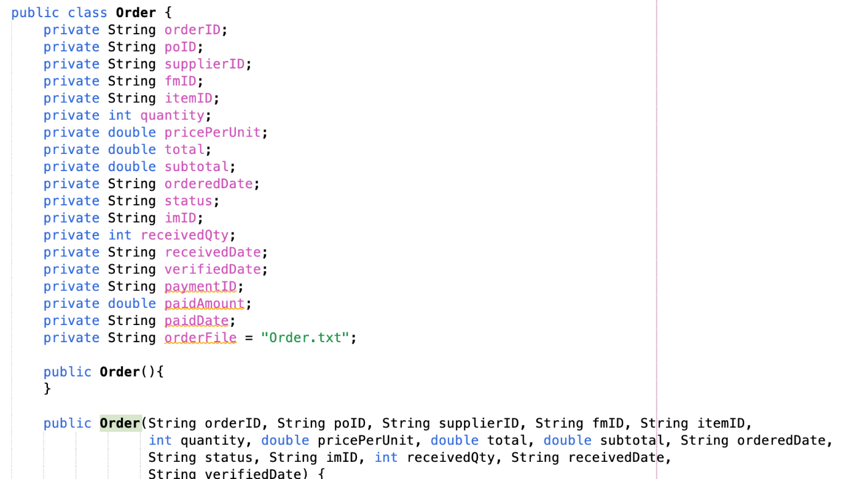

Attributes

Figure 94: Order class

* A constructor is a special method that is automatically called when the instance of the class is created. It is main to initialize the new object, usually used to set initial values for the attributes
* Two constructor is used in class are called constructor overloading. It allow system to create object in a different situation.

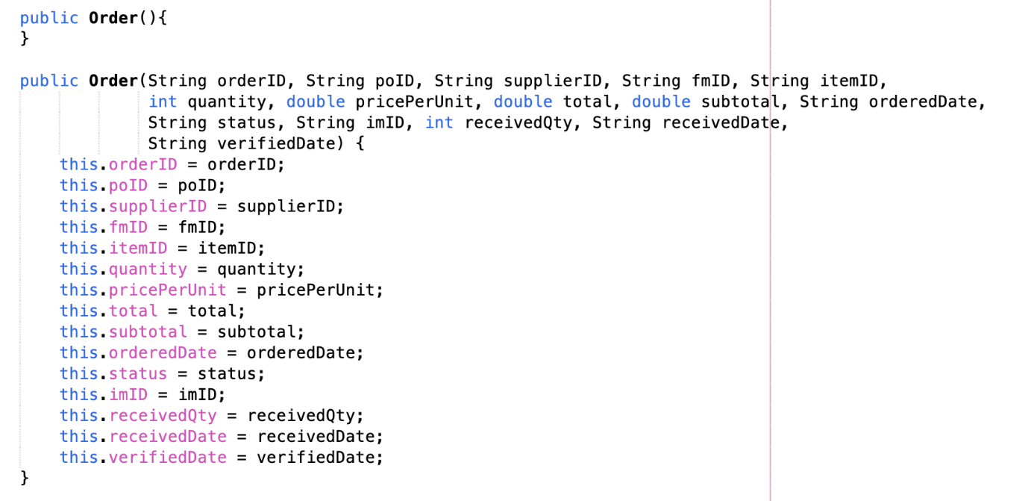

Constructor

Figure 95: Order Class (Constructor)

* Method is created with access modifier, return data type, method name and following enclosed code.

Method

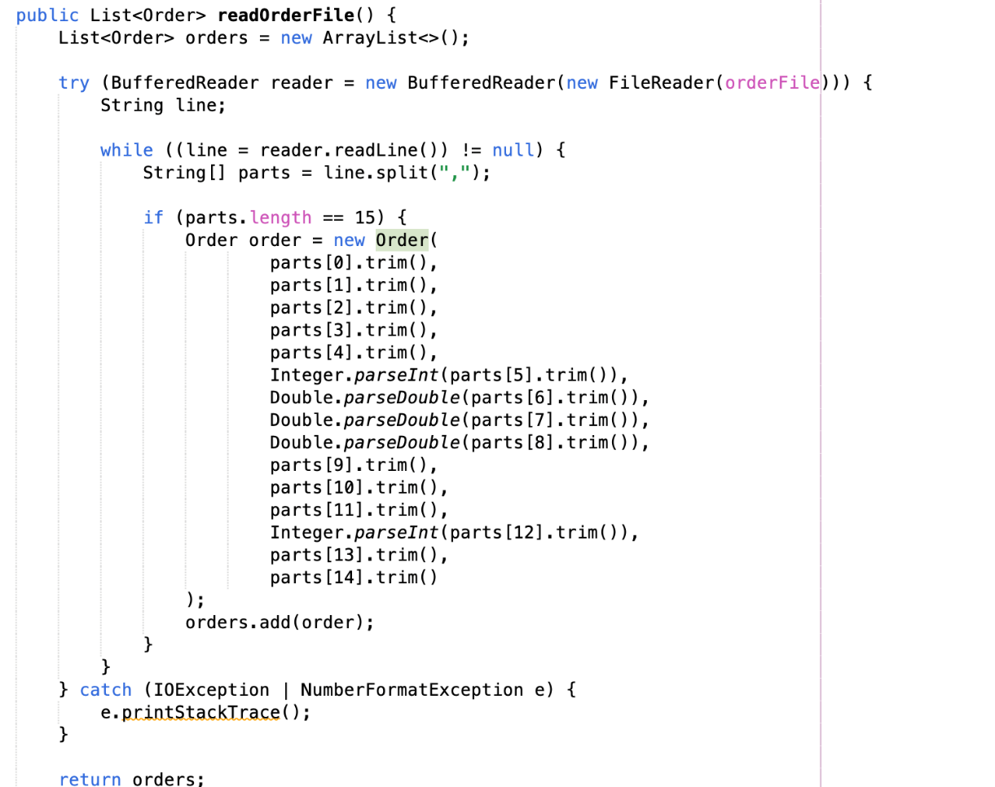

Figure 96: Order Class (Function)

Creating an instance:

* Instance is created with access modifier, class name, variable, “new” keyword and constructor.



Figure 97： Instance

**Manipulate data through object’s method:**

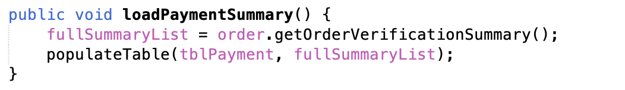

Figure 98: Call funtion

## 3.1 Encapsulation

Encapsulation is the process of combining data (attributes) and methods (functions) that operate on that data into a single entity, known as a class. It restricts direct access to parts of the object's components, keeping internal object details hidden from the outside world. This ensures the data's integrity and avoids unintentional change. Access to data is typically restricted using public methods called as getters and setters. Encapsulation increases modularity and maintainability by protecting an object's state and controlling how other program components interact with it.

In our assignment, we have created a class called **Order**. In this class, there are many of attributes and functions that define the properties and behaviours of an order. However, not every attribute or function will be accessed from outside. To ensure data integrity and avoid unintentional modification, some properties and methods are tagged as **private**, which means they can only be accessible within the class. Others may be declared as **protected**, granting access only to subclasses or classes from the same package. Attributes or methods that must be accessible to other sections of the program are identified as **public**. To give regulated access to private properties, we use **getter** and **setter** methods that provide a secure mechanism to read or alter the data. Encapsulation is the process of hiding internal features while exposing only relevant bits, which helps protect the integrity of the object's data while giving a clear interface for interaction.

Attributes in Order class:

* Usually, the attributes is private in the class.

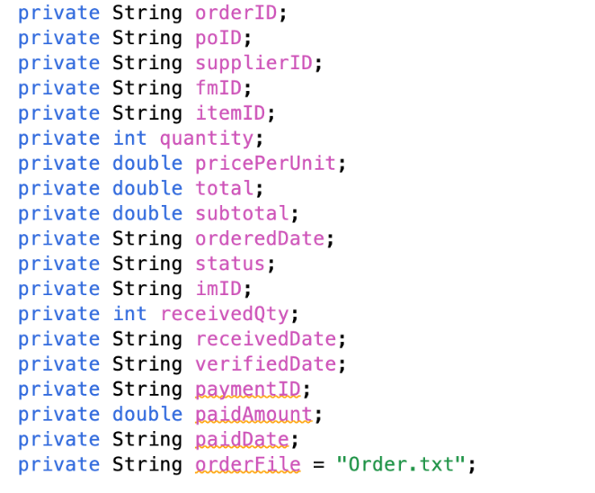

Figure 99: Attributes

**Functions in Order class:**

* Usually, functions in class is public. This is because, it should be access by the user while creating an instance of the class.

Method

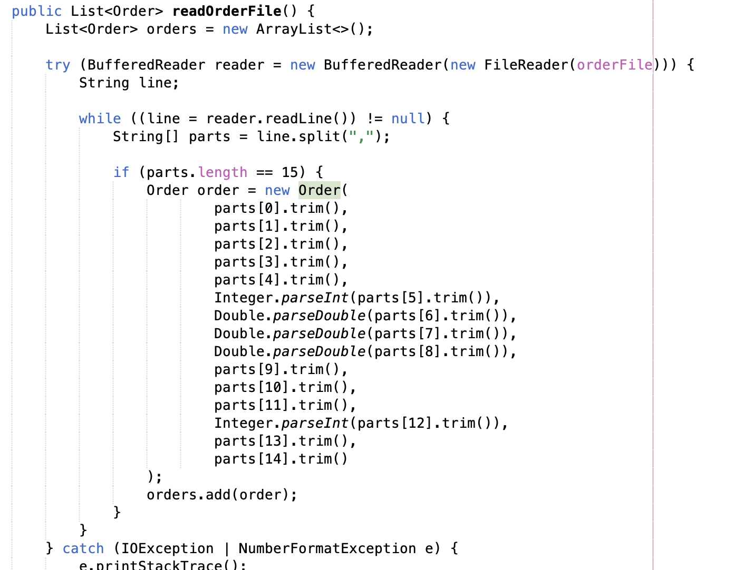

Figure 100: Method

**Getter and Setter in class:**

* We use getter and setter to access the attributes.

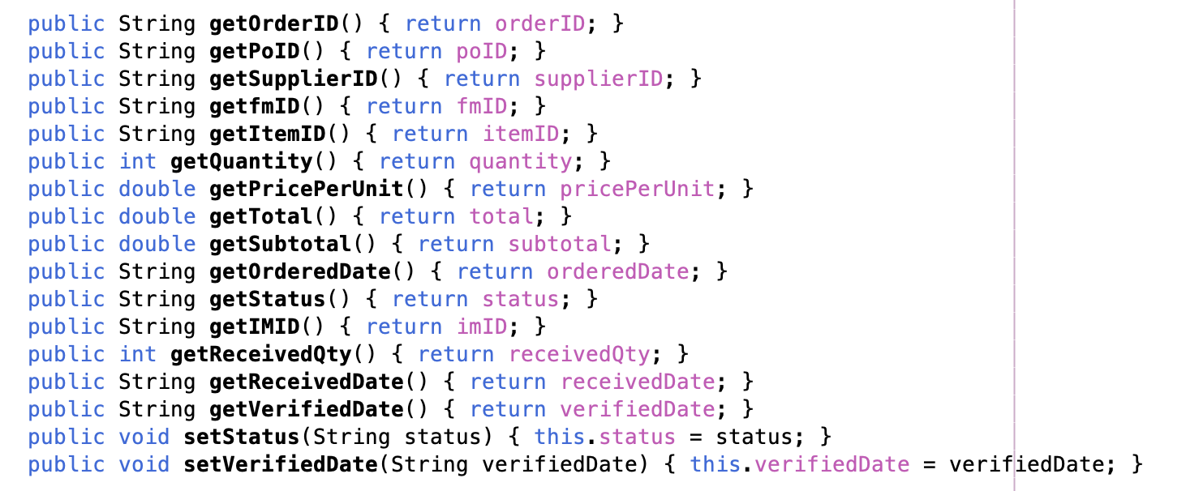

Setter

Getter

Figure 101: Getter and Setter

## 3.2 Inheritance

Inheritance allows a new class, known as a subclass or child class, to obtain properties (attributes) and behaviours (methods) from an existing class, known as the superclass or parent class. This encourages code reuse by allowing the subclass to use or override existing functionality without changing the code. Inheritance also contributes to the formation of a natural hierarchy between classes, representing "is-a" relationships; for example, a Dog class can inherit from an Animal class, inheriting broad animal qualities while adding dog-specific behaviours.

In our assignment, there is a superclass named User that is inherited by multiple child classes, including SalesManager, PurchaseManager, InventoryManager, FinanceManager, and Administrator. This generates a class hierarchy that clearly indicates that all of these roles use the system. Because of this hierarchical inheritance, all subclasses automatically inherit the attributes and methods defined in the User class, enabling code reuse and decreasing redundancy. This means that common fields such as id, name, and logout() can be declared once in the User class and utilized by all subclasses. If necessary, subclasses can override these methods to give more specialized behaviour. Furthermore, the super() keyword can be used in subclass constructors to invoke the superclass constructor, ensuring that inherited attributes are properly initialized.

**Parent class User:**

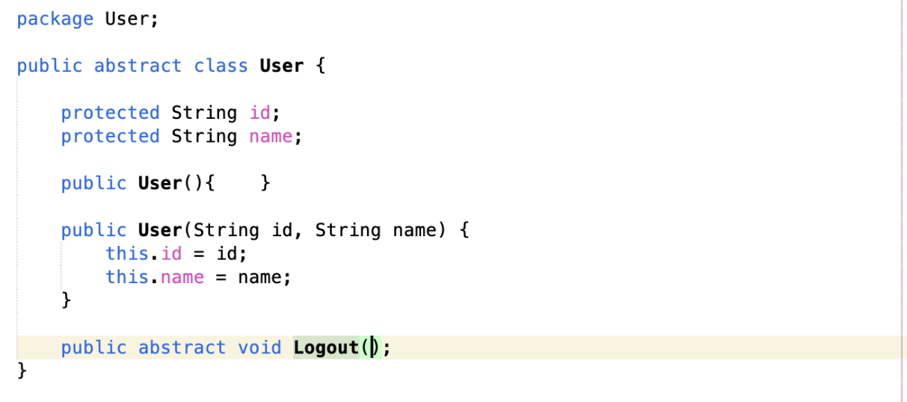

Figure 102: Parent Class User

**Sub class Finance Manager:**

* Child class will use key word “extends” to shows it is a subclass of the main class.
* Child class can use key word super() to access the attributes.

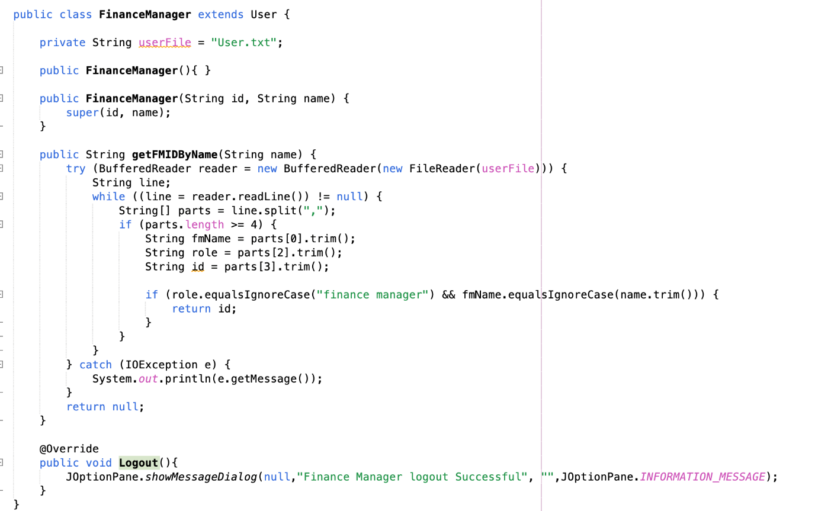

Figure 103: Sub class FinanceManager

In addition, our assignment includes a class hierarchy between Product and Item, demonstrating inheritance. The Product class is the parent class, containing common properties like itemID and itemName, whereas the Item class is the child class, inheriting from Product and adding more specialized attributes like stockLevel and price. Using super (itemID, itemName), the Item class can access and initialize the inherited attributes from Product. This demonstrates how inheritance promotes code reuse and helps organize related classes in a clear and orderly manner.

**Parent class Product:**

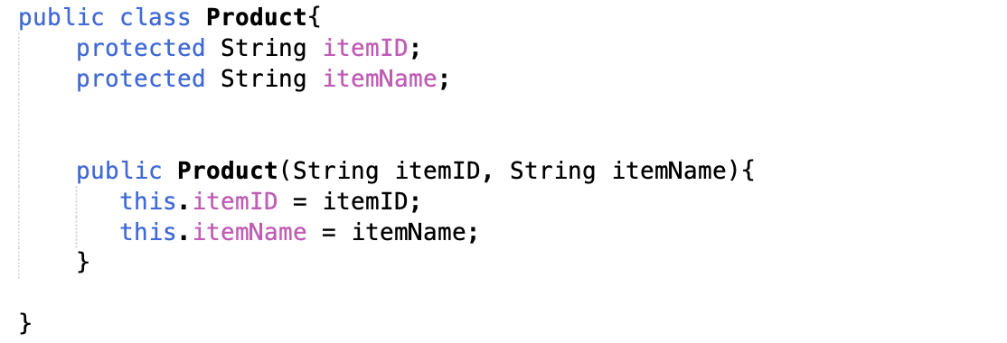

Figure 104: Parent Class Product

**Sub class Item:**

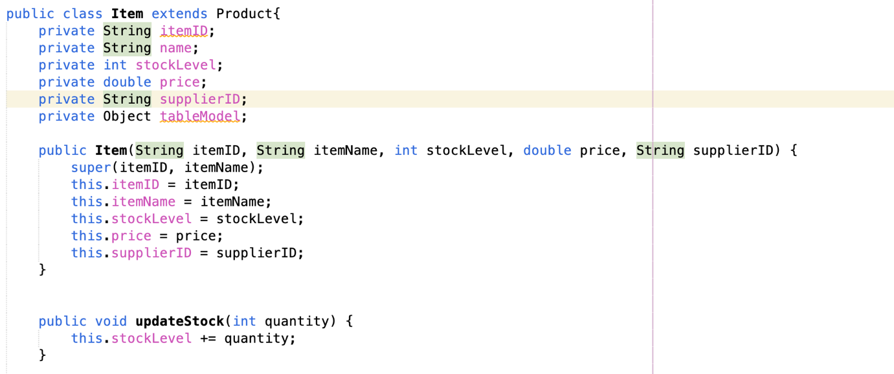

Figure 105: Sub class Item

## 3.3 Abstraction

Abstraction is a concept of hiding complex implementation details and showing only the essential features of an object. Abstraction can be associated to abstract class and interface. Abstract class cannot be instantiated but may contain an abstract method (method without body) and concrete method (method with body). Interface is a completely abstract class that defines only method signatures and can implement by classes. Besides that, abstract class and interface are superclass, concrete class must implement every method in abstract class.

In abstract class, a keyword ‘abstract’ is mandatory to declare in every method. In our assignment, there is an abstract class that define user id and username, it also contains an abstract method Logout(), which will be extended to all user class such as Administrator, FinancialManager, PurchaseManager, SalesManager and InventoryManager. For example, inventorymanager class is the concrete class that extend the logout() function a specific message when user logout successfully.

**Abstract class User:**

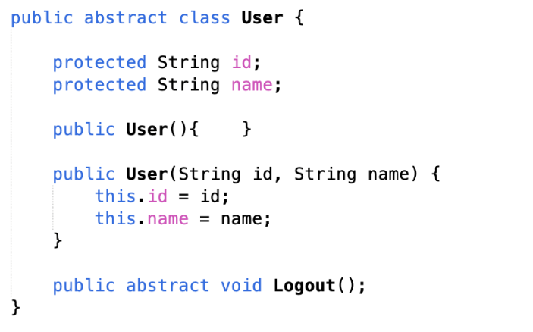

Figure 106: Abstract class

**Child class InventoryManager:**

* InventoryManager class is forced to use Logout() function and Override it.

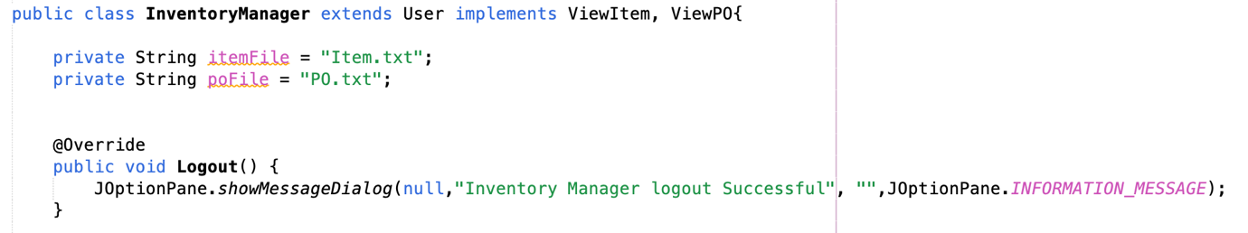

Figure 107: Abstract method

In Interface, a keyword ‘abstract’ is optional to declare in every method because all methods are abstract by default. In our assignment, there 4 interface that will optional implement in the user class such as ViewItem, ViewPO(Purchase Order), ViewPR(Purchase Requisition) and ViewSupplier. The purpose of these 4 interface is read in text file and convert it into usable data support system operational. For example, InventoryManager implement the function viewItems() inside ViewItem interface, viewItems() reads data from a file item textfile, parses each line, and populates a List<String[]> called itemList.

**Interface ViewItem:**

* A keyword “interface” is used to declare this is an interface.
* Function in interface is written with the return type and function name.

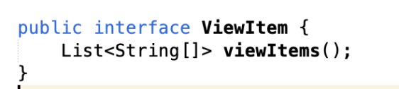

Figure 108: Interface

**Class that implements Interface ViewItem:**

* InventoryManager class use the key word “implements” to use the implements function.
* After implement, the function is forced to use in the class, and the class should override the function.

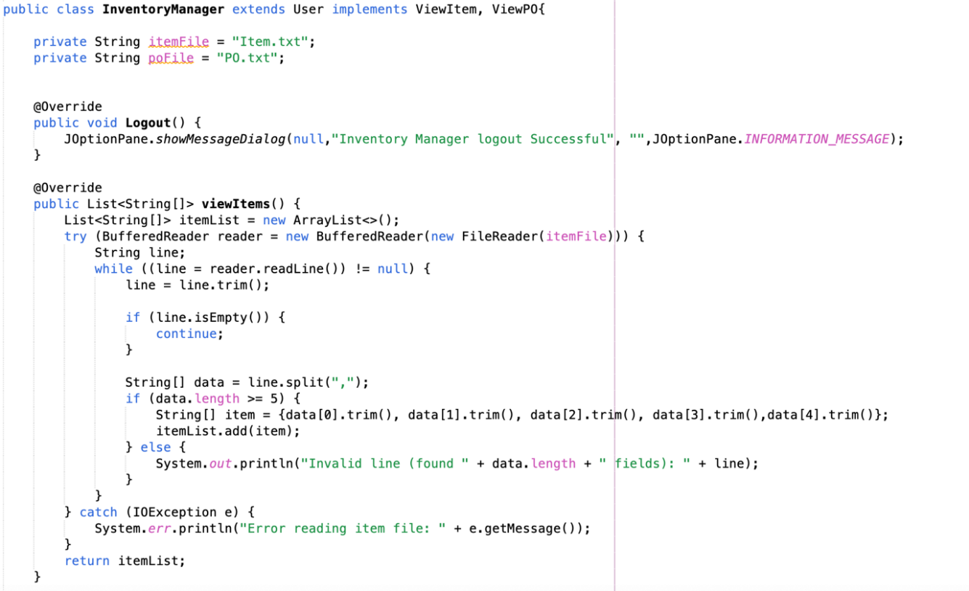

Figure 109: Interface Function

## 3.4 Polymorphism

The concept of Polymorphism is subclasses can define their own unique behaviours and share functionality of the parent class. It allows one interface or abstract class to be used for a general class of actions, it allows writing code that works on parent types, enabling flexibility and reusability in code.

### 3.4.1 Overriding

Overriding is a subclass provides a different implementation of a method that is already defined in its superclass, but subclass parameter must be the same name and type. In our assignment, Logout() is extended from User class and viewItems() is implemented from ViewItem interface, it can provide the same function with difference implementation to read the textfile from difference format and difference user. For example, InventoryManager class overriding the Logout() function to change the user role “Inventory Manager” of the message. Besides, InventoryManager class also overriding viewItems() method to read the file with the length of 5 because every user will only read the data they need in textfile.

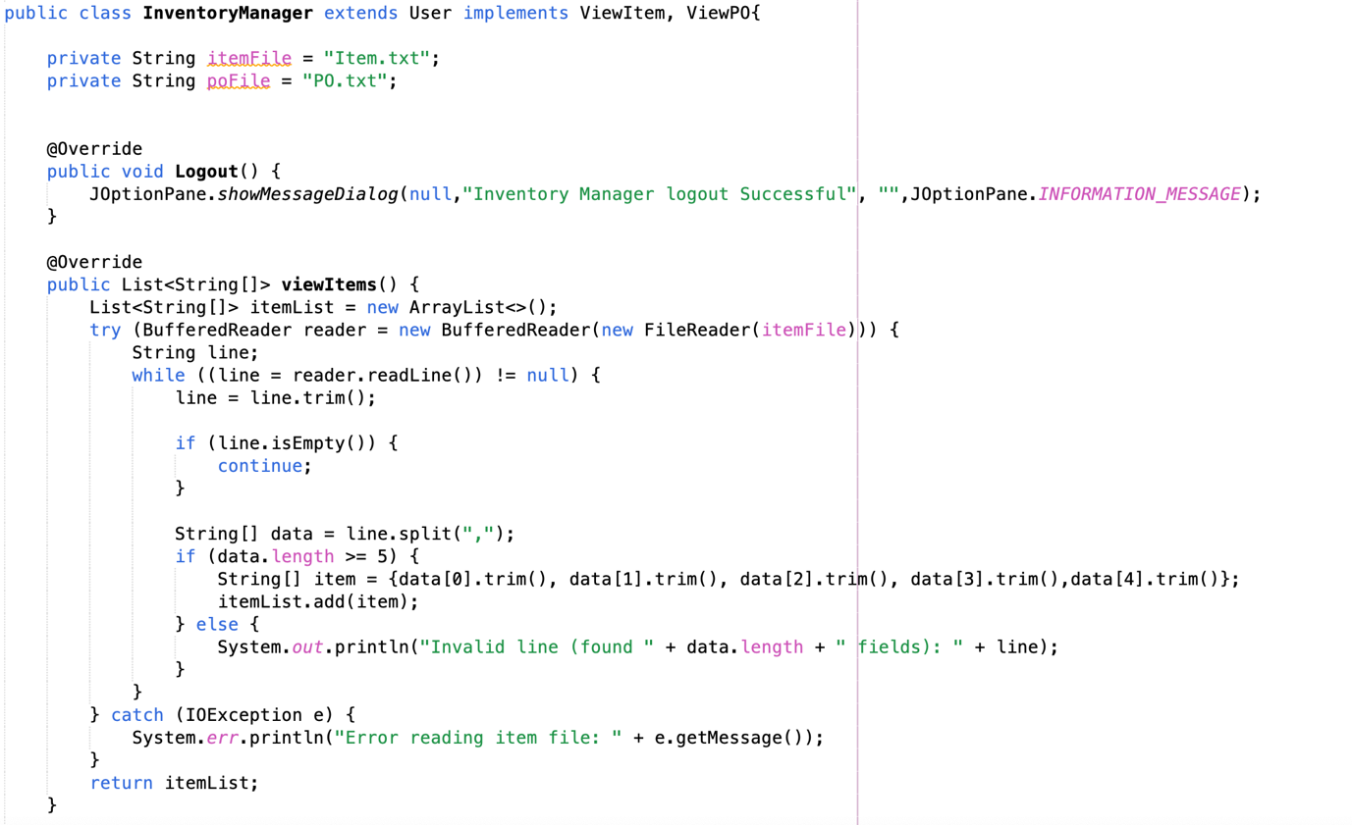

Override abstract class method

Override interface method

Figure 110: Override

### 3.4.2 Overloading

Overloading is a subclass provide two or more methods in the same class and same function name but different parameters type or argument.

For example, in the Admin class, there are three Admin constructor that accept distinct sets of parameters: one accepts nothing, another accepts complete information of admin, and the third accept csv line. This enables the same constructor to handle different types or amounts of data based on the context. Overloading enhances code readability and flexibility by allowing a method to behave differently depending on the input.

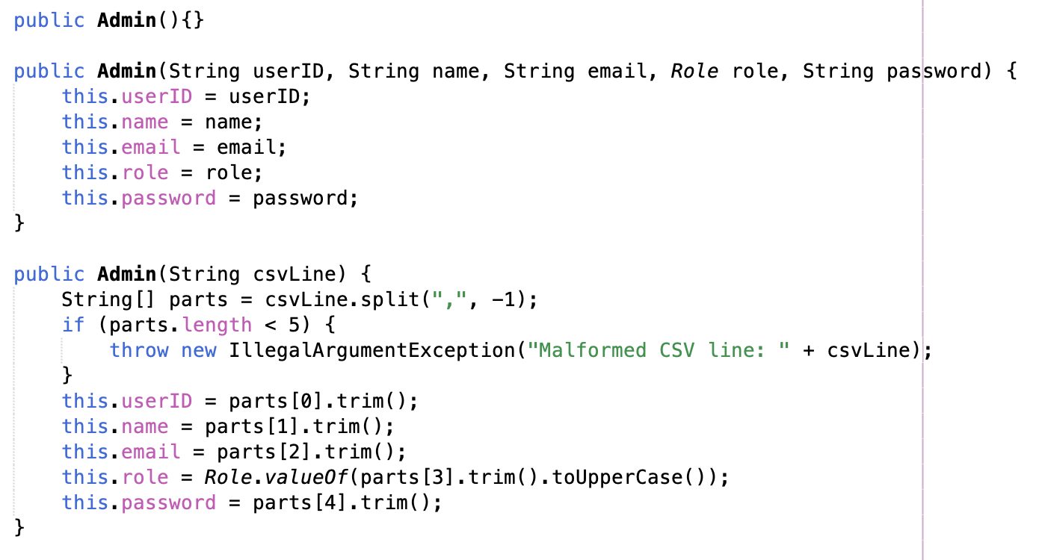

Figure 111: Overloading (Constructor)

Other than constructor, method can also fall overloading. It is the same concept but constructor is used to create object, but method don’t. For example, the admin class have three different functions but same in name. User can use the function by using different argument to use the corresponding function.

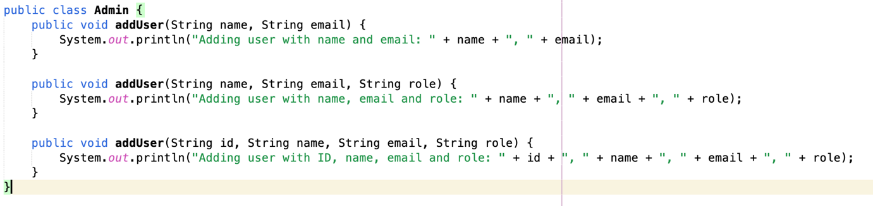

Figure 112: Overloading (Function)

# 4.0 Additional Features

## 4.1 Generate User ID automatically – Administrator

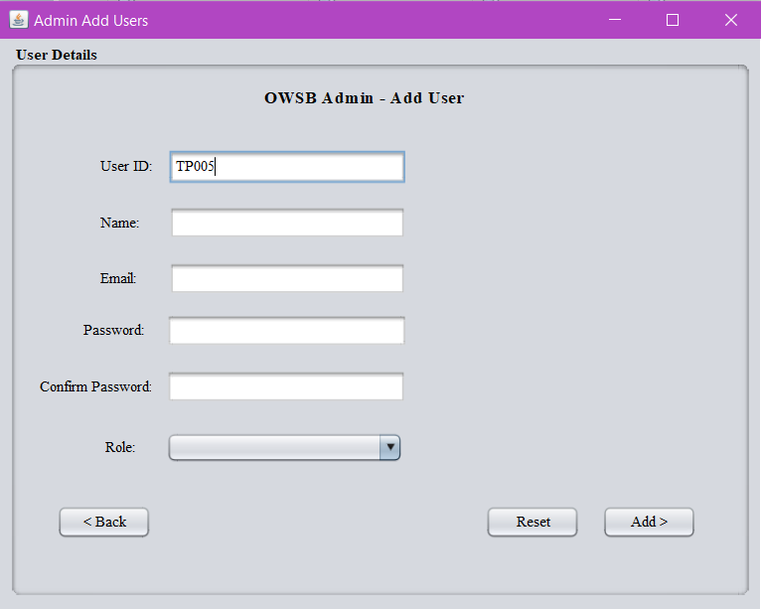

Figure 113: Auto generate User ID

Administrator needs to add a new user in a system. When admin click the “Add User >” label button, it will prompt out the “Admin Add Users” page. At the same time, the User ID text field will check and auto generate the latest User ID from our user list. The user ID text field is locked and unchangeable.

## 4.2 View Login History – Administrator



Figure 114: View Login History

Admin can view login history of each role by clicking the “View Login History” button in the Admin main page. It will prompt out the window page that contains all the login history that including User ID, Role and Timestamp (Date & Time).

## 4.3 Generate table export in CSV– Inventory Manager



Figure 115: Generate Stock Report for Inventory Manager

Inventory Manager can export table in CSV, here is the table of item details.

## 4.4 Download Payment Invoice – Finance Manager

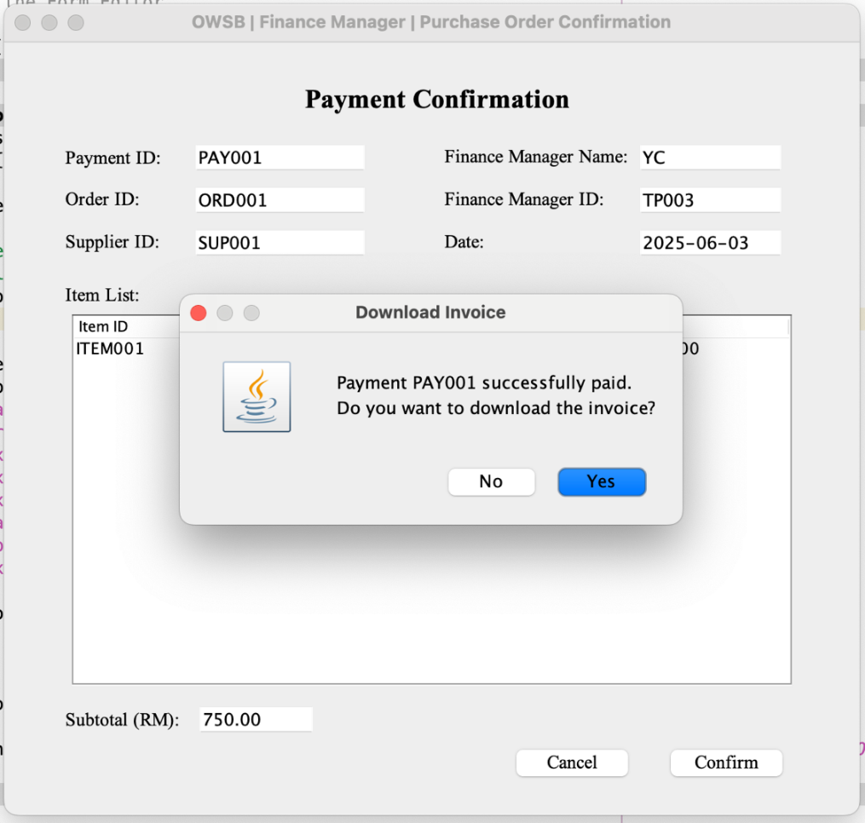

Figure 116: Download Invoice

A download invoice message box is prompted when Finance Manager successfully make the payment.

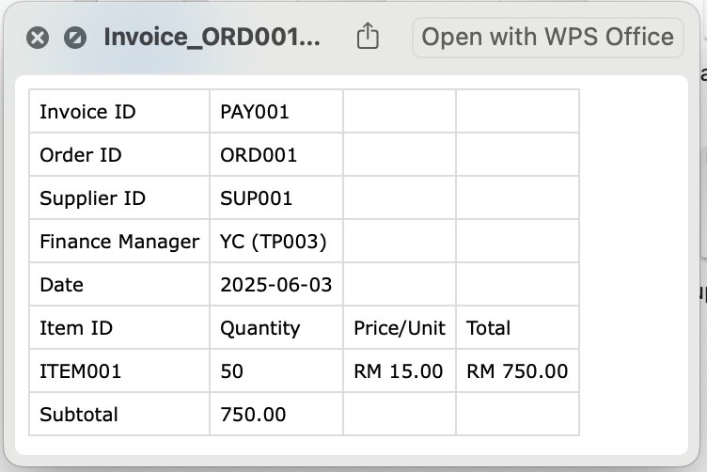

Figure 117: Invoice File

A invoice is saved in the local file once the Finance Manager press the “Yes” button.

## 4.4 Export Financial Report in CSV – Finance Manager

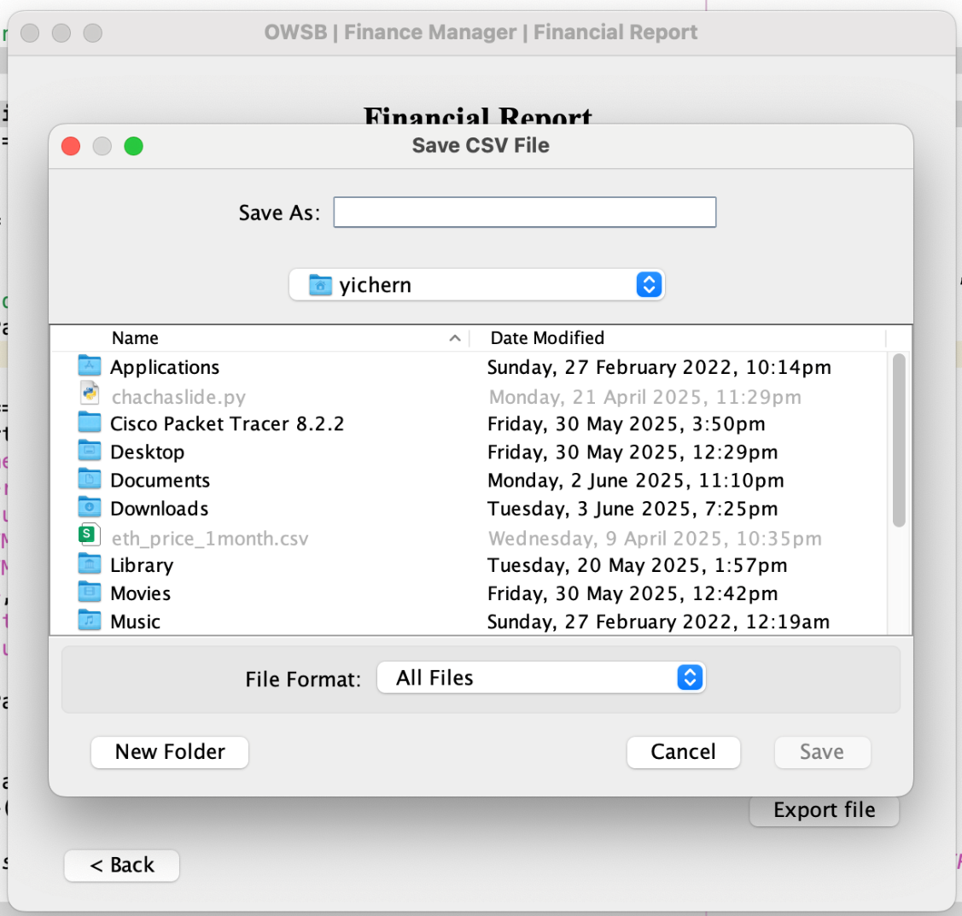

Figure 118: Save Financial Report

After Finance Manager generate monthly report, he/she can export the file in CSV format. By clicking the “Export file” button, Finance Manager will be asked to select path to save the file.

# 5.0 Limitation

In this Purchase Order Management System (OWSB), each user role, such as Administrator, Sales Manager (SM), Purchase Manager (PM), Inventory Manager (IM) and Finance Manager (FM) has distinct responsibilities and access permissions. Although this role-based structure improves in maintaining control and task separation, there is still contains several functional limitations exist within the system that might affect efficiency, accuracy and usability. One of the major limitations of the current system is that each role of users is unable to update their own profile, like change password or update email. Any changes of the profile must amend through the Admin.

Secondly, the role of Sales Manager is lacking access to automated low-stock alerts, which are the function that is only available to Inventory Manager. This means Sales Manager will overlook some important shortages as they must manually track stock levels without color-coded. Furthermore, SM is hard to make sure that suppliers can deliver requested products on time when issuing Purchase Requisitions (PR) since SM are unable to confirm real-time supplier availability.

Besides, another limitation for Purchase Manager is PM unable to reject or make comment on incorrect or incomplete PR that created by SM. Additionally, lack of supplier performance tracking is also a significant limitation. PM cannot view the historical performance, such as delivery history, delays and rating of suppliers.

Next, Administrator does not know how many Purchase Orders (PO) were generated by PM or the number of PR were created by SM. Moreover, there is a security risk because the systems do not verify the strength of the password during new user registration. For instance, it is allowing a weak password like “12345” without warning.

As for Inventory Manager, they must manually update stock levels based on authorized PO. Therefore, it may increase the human error during data input. Plus, due to the system does not include a stock history record, previous inventory changes cannot be reviewed, which makes audit trails and error corrections difficult.

Lastly, Finance Manager are unable to view an overall budget or monitor cumulative spending trends across various PO. It will be making it challenging to estimate or control procurement expenses. Financial planning is hampered, and suppliers payment supervision is weakened by this lack of budget clarity, particularly when vary quantities of purchase.

# 6.0 Conclusion

The development of the Automated Purchase Order Management System (OWSB) has demonstrated the practical application of Object-Oriented Programming (OOP) concepts in a real-world procurement environment. By designing a Java-based application, the system successfully models key business entities such as users, items, suppliers, purchase requisitions, and purchase orders using appropriate classes, attributes, and methods. The assignment showcases core OOP principles including encapsulation, inheritance, and polymorphism to ensure code reusability, modularity, and maintainability.

Moreover, role-based access control was implemented to ensure that each user type. Sales Manager, Purchase Manager, Inventory Manager, Finance Manager, and Administrator just can access the functionalities specific to their responsibilities. This separation of roles not only improves system security but also mirrors real organizational structures, thereby enhancing system usability and data integrity.

In short, this assignment has successfully fulfilled its objectives by integrating system design, role-based logic, and file handling into a comprehensive purchase order management solution tailored for Omega Wholesale Sdn Bhd.

# 7.0 References

1. W3schools. (2019). *Java Tutorial*. W3schools.com. <https://www.w3schools.com/java/default.asp>
2. Gillis, A. (2024, June). *What Is Object-Oriented Programming (OOP)?* (S. Lewis, Ed.). TechTarget. <https://www.techtarget.com/searchapparchitecture/definition/object-oriented-programming-OOP>
3. Visual Paradigm. (2019). *What is Use Case Diagram?* Visual-Paradigm.com. <https://www.visual-paradigm.com/guide/uml-unified-modeling-language/what-is-use-case-diagram/>
4. Online, S. (2023, December 29). Method overloading in java - shiksha online. Shiksha.com. <https://www.shiksha.com/online-courses/articles/method-overloading-in-java/#:~:text=Method%20overloading%20in%20Java%20means,different%20data%20types%20of%20arguments>.
5. Sandhu, R., Coyne, E. J., Feinstein, H. L., & Youman, C. E. (1996). Role-based access control models. *IEEE Computer, 29*(2), 38–47. <https://doi.org/10.1109/2.485845>
6. **Oracle. (2024).** Creating a GUI with Swing**. Java Tutorials.** <https://docs.oracle.com/javase/tutorial/uiswing/>
7. Oracle. (n.d.). *Java Platform SE 8: Class BufferedReader*. Retrieved June 3, 2025, from <https://docs.oracle.com/javase/8/docs/api/java/io/BufferedReader.html>
8. Oracle. (n.d.). *Creating a GUI with Swing*. The Java™ Tutorials. Retrieved June 3, 2025, from <https://docs.oracle.com/javase/tutorial/uiswing/>

# 8.0 Workload Matrix

